Table of contents

1. Overview 4

2. Technical Document. 7

3. Work Follow 11

3.1. Module Website 11

3.1.1. Overview. 11

3.1.2. Home page. 12

3.1.2. Authentication 13

3.1.3. Courses 14

3.1.4. Cart 16

3.1.5. Request to System. 17

3.1.6. Static page 18

3.2. Module Web Console. 19

3.2.1. Overvieww. 19

3.2.2. Role For Admin. 20

3.2.3. User For Admin 20

3.2.4. Email Configs (Modules For Admin) 21

3.2.5. Blog Manager 21

3.2.6. Request Demo For Website CMS 22

3.2.7. Courses Manager (For Website CMS ) 22

3.2.8. Contact Management ( For Website CMS ) 23

3.2.9. Pricing Management (For Website CMS) 23

3.2.10. Menu management (For Website CMS) 24

3.2.11. Email subcribe ( For website CMS ) 24

3.2.12. Faqs Management ( for website CMS) 25

3.2.13Industry Manager (Modules For Website CMS) 25

3.2.14. Policy 26

3.2.15.Download (Modules For Website CMS) 26

3.2.16. Our Clients & Testimonials Manager (Modules For Website CMS) 27

3.3. System Admin For Organization. 28

3.3.0. Overview 28

3.3.1. Dashboard Manage (Admin System) 29

3.3.2.. Course Manage (Admin System) 30

3,3.3. Training plan Manage (Admin System) 32

3.3.4. Question Bank Manage (Admin System) 33

3.3.5. Users Manage (Admin System) 34

3.3.6. Role Manage (Admin System) 35

3.3.7.Department Manage (Admin System) 36

3.3.8. Report Manage (Admin System) 38

3.3.9. Libraries Manager(Admin System) 40

3.4. System Trainees For Organization. 41

3.4.1. Overview 41

3.4.2. Trainee - My Course 42

3.4.3. Trainee - Training plan 43

3.4.4. Trainee - My Exam Attemps 44

3.4.5. Trainee - My Certificate 44

3.4.6. Trainee - My Department 45

3.4.7. Trainee - My Reminders 45

3.4.8. Trainee - My Bookmarks 46

3.4.9. Trainee - My Reports 47

4. DATABASE 48

4.1. Overview 48

5. Sercurity 55

6. Surmary. 56

**RECORD OF CHANGE**

**\*A – Added; M – Modified; D – Deleted:**

|  |  |  |  |  |
| --- | --- | --- | --- | --- |
| **Date** | **Changed Items** | **A* M, D** | **Change Description** | **New Version** |
| 10/01/2013 | All | A | Create New | V1.0 |
|  |  |  |  |  |
|  |  |  |  |  |
|  |  |  |  |  |
|  |  |  |  |  |
|  |  |  |  |  |
|  |  |  |  |  |
|  |  |  |  |  |
|  |  |  |  |  |
|  |  |  |  |  |
|  |  |  |  |  |
|  |  |  |  |  |
|  |  |  |  |  |
|  |  |  |  |  |
|  |  |  |  |  |
|  |  |  |  |  |
|  |  |  |  |  |
|  |  |  |  |  |
|  |  |  |  |  |
|  |  |  |  |  |
|  |  |  |  |  |
|  |  |  |  |  |
|  |  |  |  |  |
|  |  |  |  |  |

# 1. Overview

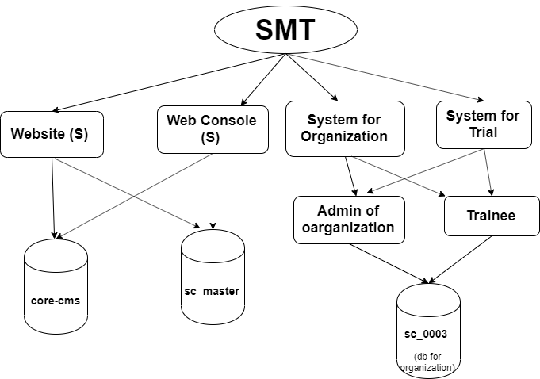

**Smart Trainer LMS (Smart Trainer LMS) have 4 System:**

- Website.

- Web console

- System for Organization

- System Trial

Requirement Common;

|  |  |  |  |
| --- | --- | --- | --- |
| Overview | | | |
|  | Requirement | Current | Note and solution |
| Technology | | | |
| OS | Os: Linux | CentOs EC2 (AWS) | ec2 (AWS) |
| Webserver | Apache or Nginx | apache (ec2) | nginx or apache |
| Database | MySQL | MySQL | RDS (AWS) |
| PHP | PHP 7.1 | php 7.1 | NA |
| Cache | Cache storage || Redis (Nullable) | cache storage | Cache Stogare and Elastic cache |
| File | use | local server | S3 (AWS) |
| Send mail | use | http send mail on local server | SNS (AWS) |
|  |  |  |  |
| Laguages | PHP  Laravel 5.3 CI AngularJs(1.5.*) | PHP  Laravel 5.3 CI AngularJs(1.5.*) |  |
|  |  |  |  |
| Libraries, third party | PayPal | PayPal |  |
| Route Domain | Manual | Manual | Auto : use Route53 (AWS) |
|  |  |  |  |
| Balance | NULLABLE | No | AWS |
|  |  |  |  |
|  |  |  |  |
| Structure project | | | |
| Website frontend | webroot/website | webroot/website | **NOTE** use : Laravel + Blade db : core-cms, sc_master |
| web console | webroot/website | webroot/website | use : Laravel + Blade db : core-cms, sc_master |
| web admin | webroot | webroot | use : Laravel + CI Controller, and Angularjs  db : db sc_organization + sc_master |
| web trainee | webroot | webroot | use : Laravel + CI Controller, and Angularjs  db : db sc_organization + sc_master |
| trial - admin | webroot/trial | webroot/trial | use : Laravel + CI Controller, and Angulars  db : db sc_trial + sc_master |
| trial- trainee | webroot/trial | webroot/trial | use : Laravel + CI Controller, and Angularjs  db : db trial + sc_master |

# 2. Technical Document.

|  |  |
| --- | --- |
| Overview | |
|  | smarttrainerlms is elearning system :  - website - Console system - Admin for Organization  - And Trainee for organization |
| How to install. | |
| Condition | Os CentOs6 ( use EC2) - Webservice: Apache 2.4 - MySQL 5.5 or hieght+ - PHP 7.1 - Git (2.x) - Composer (1.9.1 or hieght+) - NodeJs (8x) |
| Doccument | Doccument install on server **- Install Apache 2.4 for CentOs:**  https://www.digitalocean.com/community/tutorials/how-to-install-the-apache-web-server-on-centos-7 **- Install MySQL for CentOs** https://www.digitalocean.com/community/tutorials/how-to-install-mysql-on-centos-7 https://www.digitalocean.com/community/tutorials/how-to-install-linux-apache-mysql-php-lamp-stack-ubuntu-18-**04 - Install Git for CentOs:** https://www.digitalocean.com/community/tutorials/how-to-install-git-on-centos-7 **- Install Composer** https://www.vultr.com/docs/install-composer-on-centos-7 **- Install NodeJs And npm or yarn** https://www.digitalocean.com/community/tutorials/how-to-set-up-a-node-js-application-for-production-on-centos-7 |
| Checking | - Check and start Apache systemctl status httpd.service systemctl start httpd.service - MySQL systemctl status mysqld.service systemctl status mysqld.service - PHP php -v - Git git --version - Composer composer -v - Node node -v npm -v yarn -v |
| Common | |
| Clone Source | 1. you can clone source project from git on server  and checkout code to branch **"develop"** |
| Database Common | use sc_master if database not found , must you create database name is **"sc_master"** and import file sc_master.sql on MySQL ( use command line on terminal ) |
|  |  |
| Website and Console System | |
| How to config and install | **1. Go to directory is working** - Go to path : cd /path/to/webroot/website- Config .env , if file not found then copy .env.example and rename **.env 2. Next, must you config avariable fllow:** APP_ENV : is development or production APP_DEBUG : is true or false **\*, Setting Connection Database MySQL :** - Requirement : a, install MySQL and **mysqld service** is running b, use database name : **core-cms** if database name "core-cms" not found then must you create one database is "core-cms" and after, you can checking database on terminal - Config avariable on file **.env** DB_CONNECTION=mysql DB_HOST=127.0.0.1 DB_PORT=3306 DB_DATABASE=core-cms DB_USERNAME=root DB_PASSWORD=12345678 **\* Cache settings** CACHE_DRIVER=file SESSION_DRIVER=file QUEUE_DRIVER=sync **\* Mail Setting** MAIL_DRIVER= MAIL_HOST= MAIL_PORT= MAIL_USERNAME= MAIL_PASSWORD= MAIL_FROM_ADDRESS=from@example.com MAIL_FROM_NAME=Example |
|  | Run install project PHP ( Laravel 5.3 Framework)  - The first, Run vendor in /path/to/webroot/website,  Run command , composer install  After success, run command : php artisan key:generate ( create key on file .env of project/website |
| Set permission | chmod 755 for /path/to/webroot/website/storage directory |
| Setting vhost | Must you point domain to server and map vhost local us domain **Must you : point vhost to /path/to/webroot/website/public** (Doccument : https://www.digitalocean.com/community/tutorials/how-to-set-up-apache-virtual-hosts-on-ubuntu-16-04) |
| Completed | You can access website http://www.smarttrainerlms.com/ The end |
|  |  |
|  |  |
|  |  |
| Admin and Trainee System | |
| Condition | Go to directory working /path/to/webroot/ |
| Config .env | if .env file not found then you must copy .env.example to .env  **Config Database : - Requirement :** a, install MySQL and mysqld service is running b, use database name : **sc_master** if database name "**sc_master**" not found then must you create one database is "**sc_master**" and after, you can checking dabtabse on terminal **- Config avariable on file .env** DB_CONNECTION=master DB_HOST=127.0.0.1 DB_PORT=3306 DB_USERNAME=root DB_PASSWORD=12345678 DB_DATABASE=sc_master **Config cache :** CACHE_DRIVER=file SESSION_DRIVER=file QUEUE_DRIVER=sync **Config send mail** MAIL_DRIVER=smtp MAIL_HOST=mailtrap.io MAIL_PORT=2525 MAIL_USERNAME=null MAIL_PASSWORD=null MAIL_ENCRYPTION=null |
| Run project | **How to generate key :** php artisan key:generate **How to generate secret key jwt** php artisan jwt:secret Run vendor composer install |
| Run JS Packages | How to install node_modules dependency and libariy angularJs npm install (or yarn install ) bower install |
| Permission Directory | sudo chmod -R 0775 storage/framework rm -rf storage/framework/cache/* |
| Setup vhost | Must you point domain to server and map vhost local us domain **Must you : point vhost to /path/to/webroot/public** (Document : https://www.digitalocean.com/community/tutorials/how-to-set-up-apache-virtual-hosts-on-ubuntu-16-04) |
| Completed | You can access website http://www.demo.smarttrainerlms.com/admin Admin : http://www.demo.smarttrainerlms.com/admin Trainee : http://www.demo.smarttrainerlms.com/trainee The end |

# 3. Work Follow

## 3.1. Module Website

### 3.1.1. Overview.

Work follow of website frontend.

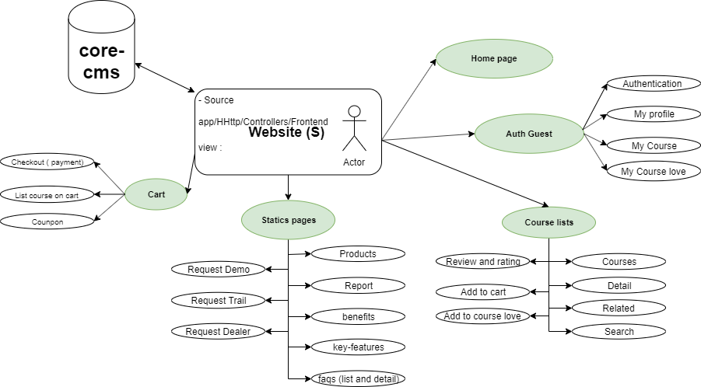

### 3.1.2. Home page.

|  |  |  |  |
| --- | --- | --- | --- |
| Homepage (Modules For Website Frontend) | | | |
| Function Name | Source | Table | Condition and Logic |
| Homepage | Frontend/HomepageController.php | courses industry  posts | Get course on homepage All industry |
|  |  |  |  |
|  |  |  |  |
| issue | | solution | |
| hard code | | define constant | |
| save file to current save | | use s3 (AWS) | |
|  | |  | |
|  | |  | |

### 3.1.2. Authentication

a. Work follow.

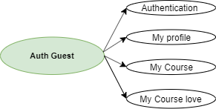

|  |  |  |  |
| --- | --- | --- | --- |
| Auth (Modules For Website Frontend) | | | |
| Function Name | Source | Table | Condition and Logic |
| Login | Frontend/RegisterController.php | users | check user and login website |
| Register | Frontend/RegisterController.php | users | - check and save data into users table - send mail |
| Reset pwd | Frontend/RegisterController.php | users | reset pwd send mail |
| My profile | Frontend/RegisterController.php | users | - check and save data into users table |
| Logout | Frontend/RegisterController.php |  | Logout to website |
|  |  |  |  |
| My courses-purchased | Frontend/CoursesPurchasedController,php | users course  transaction course_review course_like | Get data from mutiple tables |
| My courses-love | Frontend/CoursesLoveController,php | users course  transaction course_review course_like | Get data from mutiple tables |
|  |  |  |  |
|  |  |  |  |
| issue | | solution | |
| hard code | | define constant | |
| Save file to current save | | Use s3 (AWS) | |
| Coding convention | | Sub function child | |
| Warring performance : queries in for loop (My courses-purchased ) | | Height performance function | |
|  | |  | |
|  | |  | |

### 3.1.3. Courses

a. Work follow.

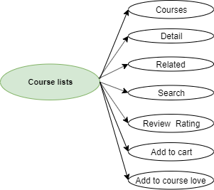

|  |  |  |  |
| --- | --- | --- | --- |
| Courses (Modules For Website Frontend) | | | |
| Function Name | Source | Table | Condition and Logic |
| Get list | Frontend/CoursesController.php | courses course_categories | Get data by index page |
| Search | Frontend/CoursesController.php | courses course_categories | search and filter |
| Detail |  | courses course_review course_like transaction users |  |
| Add to love list |  | courses course_like |  |
| Add to cart |  |  |  |
| Review |  | courses course_review |  |
| Related |  | courses |  |
|  |  |  |  |
| issue | | solution | |
| hard code | | define constant | |
| Save file to current save | | Use s3 (AWS) | |
| duplicate code : get search and list page | | Common functions | |
| Warning performance queries | | Sub and height performance queries | |
|  | |  | |

### 3.1.4. Cart

*a. Workfollow*

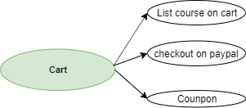

|  |  |  |  |
| --- | --- | --- | --- |
| Cart (Modules For Website Frontend) | | | |
| Function Name | Source | Table | Condition and Logic |
| My cart | Frontend/CartController.php | dealers |  |
| update | Frontend/CartController.php | use local storage |  |
| remove | Frontend/CartController.php | use local storage |  |
| Checkout to paypal | Frontend/CheckoutController.php | dealers users courses transaction | Get data and save transaction |
|  |  |  |  |
| issue | | solution | |
| Hard code | | Define constant | |
| Warning coding convention | | Sub child function | |
| Don’t use transaction | | Use | |
|  | |  | |
|  | |  | |

### 3.1.5. Request to System.

*a. Workfollow.*

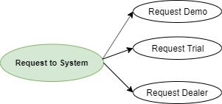

|  |  |  |  |
| --- | --- | --- | --- |
| Request* (Modules For Website Frontend) | | | |
| Function Name | Source | Table | Condition and Logic |
| Request Demo | Frontend/RequestDemosController.php | faq request_demo | Get faqs Save into request demo |
| Request Trial | Frontend/BecomeDealerController.php | pricing faq dealers sc_countries users commission industry customers | Get faqs Save into customer |
| Request Dealer | Frontend/BecomeDealerController.php | faq sc_countries users commission dealers | Get and save data into database |
|  |  |  |  |
|  |  |  |  |
| issue | | solution | |
| hard code | | Define constant | |
| Warning coding convention | | Sub child function | |
| Duplicate code **faqs** of request demo, trial, dealers | | Common function | |
|  | |  | |
|  | |  | |
|  | |  | |

### 3.1.6. Static page

*a. Workfollow.*

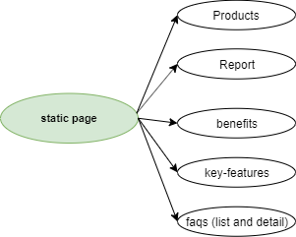

|  |  |  |  |
| --- | --- | --- | --- |
| Static pages (Modules For Website Frontend) | | | |
| Function Name | Source | Table | Condition and Logic |
| product page | Frontend/ProductController.php | NA | Static view |
| Report page | Frontend/ReportController.php | NA | Static view |
| Benefits page | Frontend/BenefitController.php | NA | Static view |
| Feature page | Frontend/KeyFeaturesController.php | NA | Static view (key, admin, trainee) |
| Faqs - List | Frontend/FaqsController.php | faqs | Get data paginate and search by keyword |
|  |  |  |  |
|  |  |  |  |
| issue | | solution | |
| Hard code | | Define constant | |
| Duplicate code - Faqs feature - Static pages | | Use common function | |
|  | |  | |

## 3.2. Module Web Console.

### 3.2.1. Overvieww.

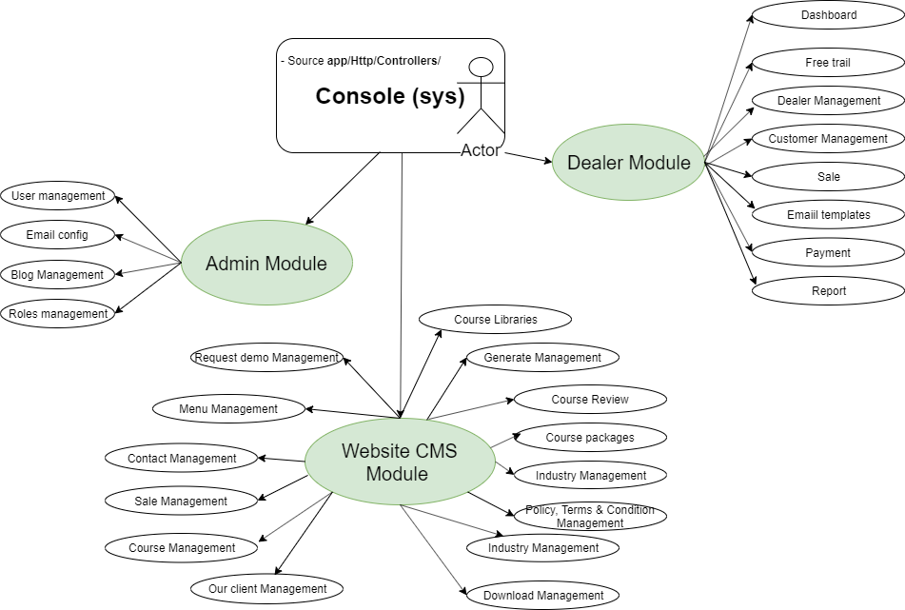

This is system manager website and user of LMS

### 3.2.2. Role For Admin.

|  |  |  |  |
| --- | --- | --- | --- |
| Roles (Modules For Admin) | | | |
| Function Name | Source | Table | Condition and Logic |
| Get list and filters | RolesController.php | roles | Get data |
| Add |  | roles | Get data and insert data |
| Edit |  | roles | Get data and insert data |
| Remove |  | roles | Get and remove item by Id |
|  |  |  |  |
| issue | | solution | |
| Don’t use send mail common functions | | Use common functions | |
| Hard code | | Define constants | |
|  | |  | |

### 3.2.3. User For Admin

|  |  |  |  |
| --- | --- | --- | --- |
| Users (Modules For Admin) | | | |
| FunctionName | Souce | Table | Condition and Logic |
| Get list and filters | Use module : contentManager RolesController.php | roles | Get data |
| Add |  | roles | Get data and insert data |
| Edit |  | roles | Get data and insert data |
| Remove |  | roles | Get and remove item by Id |
|  |  |  |  |
| issue | | solution | |
| Don’t use send mail common functions | | Use common functions | |
| hard code | | Define constants | |

### 3.2.4. Email Configs (Modules For Admin)

|  |  |  |  |
| --- | --- | --- | --- |
| Email config (Modules For Admin) | | | |
| Function Name | Source | Table | Condition and Logic |
| Get list and filters | EmailConfigController.php | email_configs | Get data |
| Add |  | email_configs | Get data and insert data |
| Edit |  | email_configs | Get data and insert data |
| Remove |  | email_configs | Get and remove item by Id |
|  |  |  |  |
|  |  |  |  |
| issue | | solution | |
|  | |  | |
|  | |  | |

### 3.2.5. Blog Manager

|  |  |  |  |
| --- | --- | --- | --- |
| Blogs (Modules For Admin) | | | |
| Function Name | Source | Table | Condition and Logic |
| Get list and filters | use: contentManager BlogController.php | posts | Get data |
| Add |  | posts | Get data and insert data |
| Edit |  | posts | Get data and insert data |
| Remove |  | posts | Get and remove item by Id |
|  |  |  |  |
|  |  |  |  |
| issue | | solution | |
|  | |  | |
|  | |  | |

### 3.2.6. Request Demo For Website CMS

|  |  |  |  |
| --- | --- | --- | --- |
| Request Demo (Modules For Website CMS) | | | |
| Function Name | Source | Table | Condition and Logic |
| Get list and filters | RequestDemoController | request_demo | Get data |
| Add |  | request_demo | Get data and insert data |
| Edit |  | request_demo | Get data and insert data  and send mail |
| Remove |  | request_demo | Get and remove item by Id |
|  |  |  |  |
| issue | | solution | |
| Don’t use common function send mail | | Use | |
| Hard code | | Define constants | |
|  | |  | |

### 3.2.7. Courses Manager (For Website CMS )

|  |  |  |  |
| --- | --- | --- | --- |
| Courses (Modules For Website CMS) | | | |
| Function Name | Source | Table | Condition and Logic |
| Get list and filters | CourseController | courses | Get data |
| add |  | courses | Get data and insert data |
| edit |  | courses | Get data and insert data  and send mail |
| remove |  | courses | Get and remove item by Id |
|  |  |  |  |
| Import Courses |  | courses generate_course  generate_modules generate_quizs | Get content xml file insert data database mutple table |
|  |  |  |  |
|  |  |  |  |
| issue | | solution | |
| Coding convention | | Sub child function | |
| Hard code | | Define constants | |
| Duplicate code | |  | |

### 3.2.8. Contact Management ( For Website CMS )

|  |  |  |  |
| --- | --- | --- | --- |
| Contact (Modules For Website CMS) | | | |
| Function Name | Source | Table | Condition and Logic |
| Get list and filters | ContacsController.php | contacts | Get data |
| Add |  | contacts | Get data and insert data |
| Edit |  | request_demo | Get data and insert data  and send mail |
| Remove |  | contacts | Get and remove item by Id |
|  |  |  |  |
|  |  |  |  |
| issue | | solution | |
| Don’t use common function send mail | | Use | |
| Hard code | | Define constants | |
|  | |  | |

### 3.2.9. Pricing Management (For Website CMS)

|  |  |  |  |
| --- | --- | --- | --- |
| Pricing (Modules For Website CMS) | | | |
| Function Name | Source | Table | Condition and Logic |
| Get list and filters | PricingController.php | contacts | Get data |
| Edit |  | contacts | Get data and insert data  and send mail |
|  |  |  |  |
| issue | | solution | |
| Don’t use common function send mail | | use | |
| Hard code | | Define constants | |
|  | |  | |

### 3.2.10. Menu management (For Website CMS)

|  |  |  |  |
| --- | --- | --- | --- |
| Menu (Modules For Website CMS) | | | |
| Function Name | Source | Table | Condition and Logic |
| Get list and filters | use : contentManager modules MenuController | post  post_meta | Get data |
| Add | use : contentManager modules MenuController | post  post_meta | Insert data |
| Edit | use : contentManager modules MenuController | post  post_meta | Get data and insert data |
| Sort | use : contentManager modules MenuController | post  post_meta |  |
| Remove | use : contentManager modules MenuController | post  post_meta |  |
|  |  |  |  |
| issue | | solution | |
|  | |  | |

### 3.2.11. Email subcribe ( For website CMS )

|  |  |  |  |
| --- | --- | --- | --- |
| Email Subcribe (Modules For Website CMS) | | | |
| FunctionName | Source | Table | Condition and Logic |
| Get list and filters | use : contentManager modules MenuController | subcribes | Get data and filter by keyword |
| Add |  | subcribes | Insert data |
| Edit |  | subcribes | Get data and insert data |
| Remove |  | subcribes | Remove by Id |
|  |  |  |  |
| issue | | solution | |
|  | |  | |
|  | |  | |

### 3.2.12. Faqs Management ( for website CMS)

|  |  |  |  |
| --- | --- | --- | --- |
| Faqs Manager (Modules For Website CMS) | | | |
| Function Name | Source | Table | Condition and Logic |
| Get list and filters | use : contentManager modules MenuController | faqs | Get data and filter by keyword |
| Add |  | faqs | insert data |
| Edit |  | faqs | get data and insert data |
| Remove |  | faqs | remove by Id |
|  |  |  |  |
| issue | | solution | |
| Hard code | | Define constant | |
|  | |  | |
|  | |  | |

### 3.2.13Industry Manager (Modules For Website CMS)

|  |  |  |  |
| --- | --- | --- | --- |
| Industry Manager (Modules For Website CMS) | | | |
| Function Name | Source | Table | Condition and Logic |
| Get list and filters |  | industry | Get data and filter by keyword |
| Add |  | industry | Insert data |
| Edit |  | industry | Get data and insert data |
| Remove |  | industry | Remove by Id |
|  |  |  |  |
|  |  |  |  |
| issue | | solution | |
| Hard code | | Define constant | |
| Save file to current save | | use s3 (AWS) | |
|  | |  | |

### 3.2.14. Policy

|  |  |  |  |
| --- | --- | --- | --- |
| Policy, Terms & Conditions Manager (Modules For Website CMS) | | | |
| FunctionName | Source | Table | Condition and Logic |
| Get list and filters | PolicyControlloer.php | policy | Get data and filter by keyword |
| Edit | PolicyControlloer.php | policy | Get data and insert data |
|  |  |  |  |
| issue | | solution | |
|  | |  | |
|  | |  | |

### 3.2.15.Download (Modules For Website CMS)

|  |  |  |  |
| --- | --- | --- | --- |
| Download Manager (Modules For Website CMS) | | | |
| Function Name | Source | Table | Condition and Logic |
| Get list and filters | DownloadController.php | download | Get data and filter by keyword |
| add | DownloadController.php | download | insert data |
| edit | DownloadController.php | download | get data and insert data |
| remove | DownloadController.php | download | remove by Id |
| issue | | solution | |
| Hard code | | Define constant | |
| Save file to current save | | use s3 (AWS) | |
|  | |  | |
|  | |  | |

### 3.2.16. Our Clients & Testimonials Manager (Modules For Website CMS)

|  |  |  |  |
| --- | --- | --- | --- |
| Our Clients & Testimonials Manager (Modules For Website CMS) | | | |
| Function Name | Source | Table | Condition and Logic |
| Get list and filters | IndustryController.php | industry | Get data and filter by keyword |
| add | IndustryController.php | industry | Insert data |
| edit | IndustryController.php | industry | Get data and insert data |
| remove | IndustryController.php | industry | Remove by Id |
|  |  |  |  |
|  |  |  |  |
| issue | | solution | |
| Hard code | | Define constant | |
| Save file to current save | | use s3 (AWS) | |
|  | |  | |

## 3.3. System Admin For Organization.

### 3.3.0. Overview

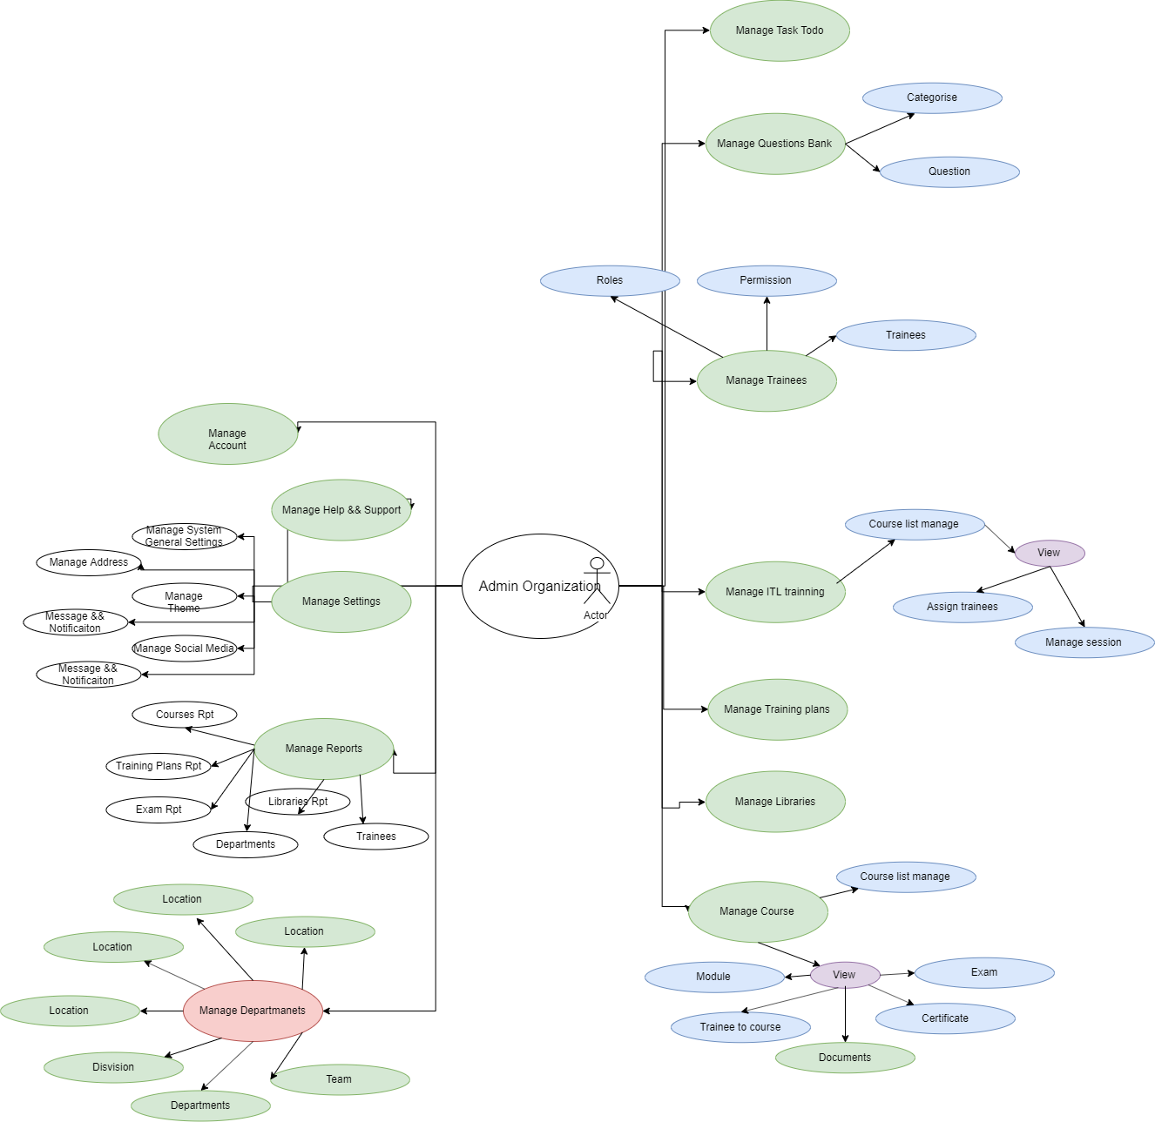

### 3.3.1. Dashboard Manage (Admin System)

|  |  |  |  |
| --- | --- | --- | --- |
| Dashboard Manage (Admin System) | | | |
| Function Name | Source | Table | Condition and Logic |
| List | CI/Admin/Dashboard.php | sc_courses sc_users sc_training_achs users course_session custom_training_plans sc_custom_courses sc_request_courses trainee_reminders assignment reminder request exam sc_custom_user_exam sc_custom_courses sc_custom_training_plans | Get data from database returing frontend |
|  |  |  |  |
|  |  |  |  |
| issue | | solution | |
| Hard code | | Define constant | |
| Coding convention | | Overwrite and use small function | |
| Query in loop | | Hight performance | |
| Duplicate code function, … | | Overwrite common function | |

### 3.3.2.. Course Manage (Admin System)

Overview :

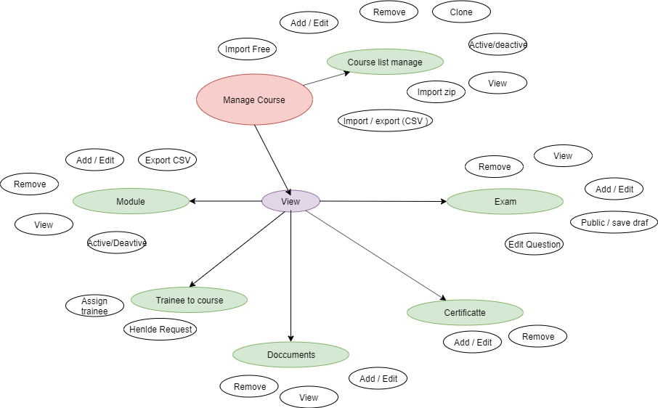

|  |  |  |  |
| --- | --- | --- | --- |
| Course Manage (Admin System) | | | |
| Function Name | Source | Table | Condition and Logic |
| List | CI/Admin/course.php | sc_courses sc_users sc_modules sc_quiz sc_department sc_location module_training_plan_complete sc_division sc_state sc_countries sc_request_courses | List and filter from sc_courses |
| Add/Edit | CI/Admin/course.php | sc_courses | Insert or update table sc_courses |
| Active / Deactice | CI/Admin/course.php | sc_courses |  |
| Request Assign | CI/Admin/course.php | sc_courses sc_department sc_custom_modules sc_modules sc_division sc_location sc_state sc_countries sc_request_courses | Update flag delete of table sc_courses by Id |
| Detail | CI/Admin/course.php | sc_courses sc_department sc_custom_modules sc_modules sc_division sc_location sc_state sc_countries sc_request_courses | Get item from table sc_courses by Id |
| Course modules | CI/Admin/modules.php | sc_users sc_modules |  |
| Course modules ADD/EDIT | CI/Admin/modules.php | sc_users sc_modules | insert or update table sc_modules |
| Course modules REEMOVE | CI/Admin/modules.php | sc_users sc_modules | Update data into table sc_modules |
|  |  |  |  |
| issue | | solution | |
| hard code | | Define constant | |
| Coding convention | | Overwrite and use small function | |
| Duplicate code | | Common functions | |
| Warning coding convention validate function | | Overwrite function validate from server | |
| Duplicate function export data | | Overwrite function library export csv | |
|  | |  | |
|  | |  | |

### 3,3.3. Training plan Manage (Admin System)

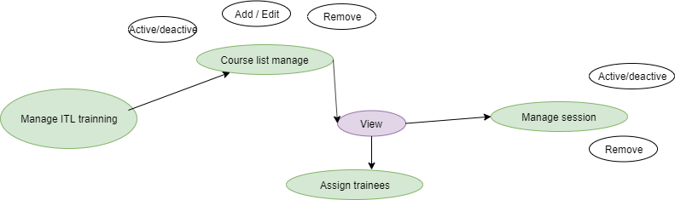

|  |  |  |  |
| --- | --- | --- | --- |
| Training plan Manage (Admin System) | | | |
| Function Name | Source | Table | Condition and Logic |
| List | CI/Admin/trainingplan.php | sc_courses sc_users sc_modules sc_quiz sc_department sc_location sc_division sc_state sc_countries sc_request_courses | List and filter from sc_courses |
| Add/Edit | CI/Admin/trainingplan.php | sc_courses | Insert or update table sc_courses |
| Active / Deactice | CI/Admin/trainingplan.php | sc_courses |  |
|  |  |  |  |
|  |  |  |  |
| issue | | solution | |
| hard code | | define constant | |
| Condting convertion | | overwrite and use small function | |
| Duplicate code | | common functions | |
| Warning coding convention validate function | | Overwrite function validate from server | |
| Duplicate function export data | | Overwrite function libary export csv | |
| Query in loop | | Hight performance query | |

### 3.3.4. Question Bank Manage (Admin System)

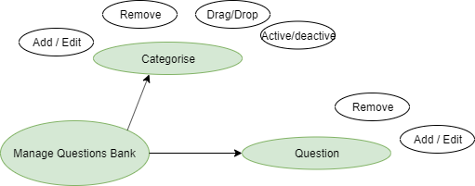

|  |  |  |  |
| --- | --- | --- | --- |
| Question Bank Manage (Admin System) | | | |
| Function Name | Source | Table | Condition and Logic |
| Category Manage | CI/Admin/questionCategory.php | sc_courses sc_users sc_customer_question_categories | List and filter from sc_courses |
| Category Manage Add/Edit | CI/Admin/questionCategory.php | sc_customer_question_categories sc_custom_exam_question_answer | Insert or update table sc_courses |
| Category Manage  Active / Deactice | CI/Admin/questionCategory.php | sc_customer_question_categories sc_custom_exam_question_answer |  |
|  |  |  |  |
| Manage | CI/Admin/question.php | ss_questions sc_module sc_answers | Import data from table question module and answer |
| ADD/EDIT | CI/Admin/question.php | ss_questions sc_module sc_answers | Update questions |
| Remove | CI/Admin/question.php | ss_questions  sc_answers | Update questions |
| Imports |  |  |  |
|  |  |  |  |
| issue | | solution | |
| Hard code | | Define constant | |
| Condting convertion | | Overwrite and use small function | |
| Duplicate code | | Common functions | |
| Warning coding convention validate function | | Overwrite function validate from server | |
| Duplicate function export data | | Overwrite function library export csv | |
|  | |  | |

### 3.3.5. Users Manage (Admin System)

|  |  |  |  |
| --- | --- | --- | --- |
| Users Manage (Admin System) | | | |
| FunctionName | Souce | Table | Condition and Logic |
| User Manage | CI/Admin/users.php | sc_department sc_location sc_roles sc_countries sc_state sc_division sc_user_roles sc_users | Get data from mutiple databases |
| User Manage Add / Edit | CI/Admin/users.php | sc_department sc_location sc_roles sc_countries sc_state sc_division sc_user_roles sc_users | Insert or update table sc_users and get data from mutiple table |
| User manage Remove | CI/Admin/users.php | sc_users | Update sc_users |
| Imports |  |  |  |
|  |  |  |  |
| issue | | solution | |
| hard code | | Define constant | |
| Coding convention | | Overwrite and use small function | |
| Duplicate code | | Common functions | |
| Warning coding convention validate function | | Overwrite function validate from server | |
|  | |  | |

### 3.3.6. Role Manage (Admin System)

|  |  |  |  |
| --- | --- | --- | --- |
| Role Manage (Admin System) | | | |
| Function Name | Source | Table | Condition and Logic |
| Role list | CI/Admin/role.php | sc_roles_permissions sc_user_roles sc_users sc_roles | Get data from multiple databases |
| Add edit | CI/Admin/role.php | sc_roles_permissions sc_user_roles sc_users sc_roles | Insert or update table sc_roles and get data from mutiple table |
| Remove | CI/Admin/role.php | sc_roles | Update sc_roles |
|  |  |  |  |
|  |  |  |  |
| Sync Permission | CI/Admin/permission.php | sc_role_permission | Update table |
|  |  |  |  |
|  |  |  |  |
| issue | | solution | |
| Hard code | | Define constant | |
| Coding convention | | Overwrite and use small function | |
| Duplicate code | | Common functions | |
| Warning coding convention validate function | | Overwrite function validate from server | |
|  | |  | |
|  | |  | |

### 3.3.7.Department Manage (Admin System)

Overview work follow

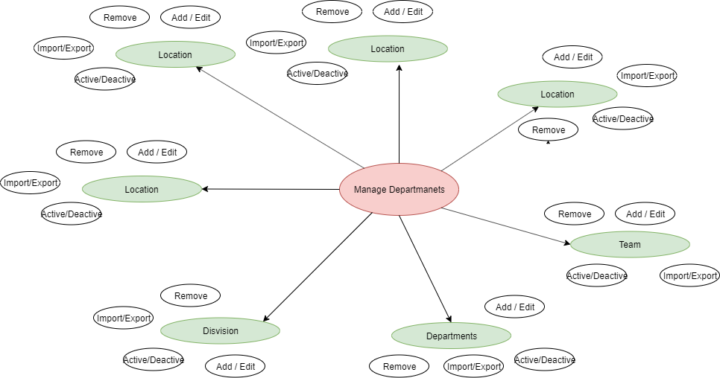

|  |  |  |  |
| --- | --- | --- | --- |
| Department Manage (Admin System) | | | |
| Function Name | Source | Table | Condition and Logic |
| List | CI/Admin/department.php | sc_department sc_division sc_state sc_countries sc_location | Get data from multiple databases |
| Add edit | CI/Admin/department.php | sc_department sc_division sc_state sc_countries sc_location | Insert or update table sc_department and get data from mutiple table |
| Remove | CI/Admin/department.php | sc_department | Update sc_department |
|  |  |  |  |
|  |  |  |  |
| Sync Permission | CI/Admin/permission.php | sc_role_permission | update table |
|  |  |  |  |
| issue | | solution | |
| hard code | | Define constant | |
| Coding convention | | Overwrite and use small function | |
| Duplicate code | | Common functions | |
| Warning coding convention validate function | | Overwrite function validate from server | |
| Export function duplicate | | Common functions | |
|  | |  | |

### 3.3.8. Report Manage (Admin System)

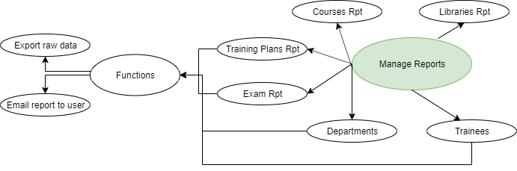

|  |  |  |  |
| --- | --- | --- | --- |
| Report Manage (Admin System) | | | |
| Function Name | Source | Table | Condition and Logic |
| Library | CI/Admin/library.php | sc_libraries sc_departments |  |
| Course | CI/Admin/course.php | sc_libraries sc_courses |  |
| Training | CI/Admin/training.php | sc_courses sc_users sc_modules sc_quiz sc_department sc_location sc_division sc_state sc_countries sc_request_courses |  |
| Exam && cert | CI/Admin/exam.php | sc_document sc_user sc_certificates sc_custom_user_certificates |  |
| Department | CI/Admin/department.php | sc_department sc_location sc_division sc_state sc_countries |  |
|  |  |  |  |
|  |  |  |  |
| issue | | solution | |
| Hard code | | Define constant | |
| Coding convention | | Overwrite and use small function | |
| Duplicate code | | Common functions | |
| Warning coding convention validate function | | Overwrite function validate from server | |
| Export function duplicate | | Common functions | |
|  | |  | |
|  | |  | |

### 3.3.9. Libraries Manager(Admin System)

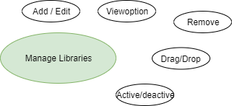

|  |  |  |  |
| --- | --- | --- | --- |
| Libraries Manage (Admin System) | | | |
| Function Name | Source | Table | Condition and Logic |
| List | CI/Admin/Library.php | sc_libraries | List and filter from libraries |
| Add/Edit | CI/Admin/Library.php | sc_libraries | Insert or update table libraries |
| Active / Deactice | CI/Admin/Library.php | sc_libraries |  |
| Delete | CI/Admin/Library.php | sc_libraries sc_departments | Update flag delete of table libraries by Id |
| Detail lib | CI/Admin/Library.php | sc_libraries | Get item from table libraries by Id |
| Add Library Course | CI/Admin/Library.php | sc_libraries | insert into table sc_libraries |
|  |  |  |  |
|  |  |  |  |
|  |  |  |  |
| issue | | solution | |
| hard code | | Define constant | |
| Coding convention | | Overwrite and use small function | |
| Duplicate code | | Common functions | |
|  | |  | |

## 3.4. System Trainees For Organization.

### 3.4.1. Overview

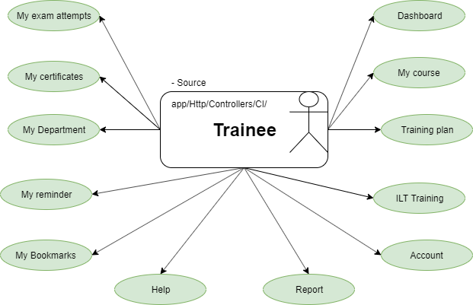

### 3.4.2. Trainee - My Course

|  |  |  |  |
| --- | --- | --- | --- |
| Trainee - My Course | | | |
| FunctionName | Source | Table | Condition and Logic |
| Training course and Filter | CI/Trainee/smartcode.php | sc_libraries sc_custom_courses sc_request_courses | Get data from multiple tables |
| Course Requested and Filter | CI/Admin/course.php | sc_libraries sc_custom_courses sc_request_courses | Get data from multiple tables |
| All Course and Filter | CI/Admin/training.php | sc_libraries sc_custom_courses sc_request_courses | Get data from multiple tables |
|  |  |  |  |
| issue | | solution | |
| Hard code | | Define constant | |
| Coding convention | | Overwrite and use small function | |
| Duplicate code ( function filter, paginate, all_course, course_requested, ... | | Common functions; | |
| Warning coding convention validate function | | Overwrite function validate from server | |
|  | |  | |
|  | |  | |

### 3.4.3. Trainee - Training plan

|  |  |  |  |
| --- | --- | --- | --- |
| Trainee - Training plan | | | |
| FunctionName | Source | Table | Condition and Logic |
| Remain training plans and Filter | CI/Trainee/trainingplan.php | sc_libraries sc_custom_courses sc_request_courses sc_custom_training_plans | Get data from multiple tables |
| Completed training plans and Filter | CI/Trainee/trainingplan.php | sc_libraries sc_custom_courses sc_request_courses sc_custom_training_plans | Get data from multiple tables |
| Expried training plans and Filter | CI/Trainee/trainingplan.php | sc_libraries sc_custom_courses sc_request_courses sc_custom_training_plans | Get data from multiple tables |
|  |  |  |  |
|  |  |  |  |
| issue | | solution | |
| Hard code | | Define constant | |
| Coding convention | | Overwrite and use small function | |
| Duplicate code ( function filter, paginate, all_course, course_requested, ... | | Common functions; | |
| Warning coding convention validate function | | Overwrite function validate from server | |
|  | |  | |

### 3.4.4. Trainee - My Exam Attemps

|  |  |  |  |
| --- | --- | --- | --- |
| Trainee - My ILT Training | | | |
| FunctionName | Souce | Table | Condition and Logic |
| Remain training plans and Filter | CI/Trainee/smartcode.php | sc_custom_courses sc_custom_user_exam sc_custom_training_plans | Get data from multiple tables |
|  |  |  |  |
|  |  |  |  |
| issue | | solution | |
| Hard code | | Define constant | |
| Coding convention | | Overwrite and use small function | |
| Duplicate code ( function filter, paginate, all_course, course_requested, ... | | Common functions; | |
| Query in loop | | Hight performance | |
|  | |  | |
|  | |  | |

### 3.4.5. Trainee - My Certificate

|  |  |  |  |
| --- | --- | --- | --- |
| Trainee - My Certificate | | | |
| FunctionName | Souce | Table | Condition and Logic |
| Exam | CI/Trainee/exam.php | sc_custom_user_certificates sc_request_courses | Get data from multiple tables |
| Add/Edit | CI/Trainee/exam.php | sc_custom_user_certificates | Insert or Update |
| Remove | CI/Trainee/exam.php | sc_custom_user_certificates | Remove |
|  |  |  |  |
|  |  |  |  |
| issue | | solution | |
| Hard code | | Define constant | |
| Coding convention | | Overwrite and use small function | |
|  | |  | |

### 3.4.6. Trainee - My Department

|  |  |  |  |
| --- | --- | --- | --- |
| Trainee - My Department | | | |
| FunctionName | Source | Table | Condition and Logic |
| Exam | CI/Trainee/department.php | sc_department sc_users sc_division sc_location sc_state sc_countries | Get data from multiple tables |
| Add/Edit | CI/Trainee/exam.php | sc_custom_user_certificates | Insert or Update |
| Remove | CI/Trainee/exam.php | sc_custom_user_certificates | Remove |
|  |  |  |  |
| issue | | solution | |
| Hard code | | Define constant | |
| Coding convention | | Overwrite and use small function | |
|  | |  | |

### 3.4.7. Trainee - My Reminders

|  |  |  |  |
| --- | --- | --- | --- |
| Trainee - My Reminders | | | |
| FunctionName | Source | Table | Condition and Logic |
| Get list | CI/Trainee/smartcode.php | sc_trainee_reminders sc_custom_courses, sc_request_courses  sc_custom_training_plans, sc_request_courses sc_custom_modules | Get data from multiple tables |
| Add/Edit | CI/Trainee/smartcode.php | sc_trainee_reminders | Insert or Update |
| Remove | CI/Trainee/smartcode.php | sc_trainee_reminders | Remove |
|  |  |  |  |
| issue | | solution | |
| Hard code | | Define constant | |
| Coding convention | | Coding convention | |
| Duplicate function | | Overwrite and use common function | |
|  | |  | |

### 3.4.8. Trainee - My Bookmarks

|  |  |  |  |
| --- | --- | --- | --- |
| Trainee - My Bookmarks | | | |
| FunctionName | Source | Table | Condition and Logic |
| Get list | CI/Trainee/bookmark.php | sc_bookmarks sc_users | Get data from multiple tables |
| Add/Edit | CI/Trainee/bookmark.php | sc_bookmarks sc_users | Insert or Update |
| Remove | CI/Trainee/bookmark.php | sc_bookmarks sc_users | Remove |
|  |  |  |  |
|  |  |  |  |
| issue | | solution | |
| Hard code | | Define constant | |
| Coding convention | | Coding convention | |
| Duplicate function | | Overwrite and use common function | |
|  | |  | |
|  | |  | |

### 3.4.9. Trainee - My Reports

|  |  |  |  |
| --- | --- | --- | --- |
| Trainee - My Reports | | | |
| FunctionName | Source | Table | Condition and Logic |
| My Own Report | CI/Trainee/dashboard.php | sc_bookmarks sc_users sc_request_courses sc_custom_courses sc_custom_modules sc_custom_user_exam sc_certificates | Get data from multiple tables |
| My Department Report | CI/Trainee/dashboard.php | sc_bookmarks sc_users sc_request_courses sc_custom_courses sc_custom_modules sc_custom_user_exam sc_certificates | Get data from multiple tables |
|  |  |  |  |
|  |  |  |  |
| issue | | solution | |
| Hard code | | Define constant | |
| Coding convention | | Coding convention | |
| Duplicate function | | Overwrite and use common function | |
|  | |  | |
|  | |  | |

# 4. DATABASE

## 4.1. Overview

|  |  |  |
| --- | --- | --- |
| **core-cms** | | |
| **No** | **TableName** | **Note** |
| 1 | comments |  |
| 2 | commission |  |
| 3 | contact_custom |  |
| 4 | contacts |  |
| 5 | course_categories |  |
| 6 | course_likes |  |
| 7 | course_packages |  |
| 8 | course_reviews |  |
| 9 | courses |  |
| 10 | customers |  |
| 11 | dealers |  |
| 12 | download |  |
| 13 | email_configs |  |
| 14 | email_settings |  |
| 15 | email_short_codes |  |
| 16 | faq |  |
| 17 | galleries |  |
| 18 | gallery_images |  |
| 19 | generate_courses |  |
| 20 | generate_exam_answers |  |
| 21 | generate_exam_questions |  |
| 22 | generate_exams |  |
| 23 | generate_modules |  |
| 24 | generate_question_types |  |
| 25 | generate_quizs |  |
| 26 | get_touch |  |
| 27 | industry |  |
| 28 | membership_type |  |
| 29 | migrations |  |
| 30 | options |  |
| 31 | our_clients |  |
| 32 | password_resets |  |
| 33 | payments |  |
| 34 | payments_history |  |
| 35 | post_meta |  |
| 36 | posts |  |
| 37 | pricing |  |
| 38 | pricing_register |  |
| 39 | privacy |  |
| 40 | request_demo |  |
| 41 | roles |  |
| 42 | sc_countries |  |
| 43 | send_emails |  |
| 44 | subscribe |  |
| 45 | term_relationships |  |
| 46 | terms |  |
| 47 | theme_meta |  |
| 48 | themes |  |
| 49 | transaction |  |
| 50 | type_customer |  |
| 51 | user_meta |  |
| 52 | users |  |
| 53 | widget_groups |  |
| 54 | widgets |  |

|  |  |  |
| --- | --- | --- |
| **sc_0003 ( sc_organization)** | | |
| **No** | **TableName** | **Note** |
| 1 | sc_actions |  |
| 2 | sc_answers |  |
| 3 | sc_article |  |
| 4 | sc_bookmarks |  |
| 5 | sc_bunit |  |
| 6 | sc_category |  |
| 7 | sc_certificates |  |
| 8 | sc_company_types |  |
| 9 | sc_content_comments |  |
| 10 | sc_contents |  |
| 11 | sc_countries |  |
| 12 | sc_course_session |  |
| 13 | sc_courses |  |
| 14 | sc_custom_courses |  |
| 15 | sc_custom_document |  |
| 16 | sc_custom_exam |  |
| 17 | sc_custom_exam_question |  |
| 18 | sc_custom_exam_question_answer |  |
| 19 | sc_custom_modules |  |
| 20 | sc_custom_training_plans |  |
| 21 | sc_custom_user_certificates |  |
| 22 | sc_custom_user_exam |  |
| 23 | sc_custom_user_exam_question |  |
| 24 | sc_custom_user_exam_question_answer |  |
| 25 | sc_customer_question_categories |  |
| 26 | sc_department |  |
| 27 | sc_division |  |
| 28 | sc_email_template |  |
| 29 | sc_entities |  |
| 30 | sc_exam_attempts |  |
| 31 | sc_exam_details |  |
| 32 | sc_group_chat |  |
| 33 | sc_language |  |
| 34 | sc_language_nation |  |
| 35 | sc_last_seen |  |
| 36 | sc_libraries |  |
| 37 | sc_libraries_custom |  |
| 38 | sc_location |  |
| 39 | sc_location_type |  |
| 40 | sc_menus |  |
| 41 | sc_messages |  |
| 42 | sc_messages_group |  |
| 43 | sc_module_completed |  |
| 44 | sc_module_training |  |
| 45 | sc_module_training_plan_complete |  |
| 46 | sc_modules |  |
| 47 | sc_notifications |  |
| 48 | sc_permissions |  |
| 49 | sc_plans |  |
| 50 | sc_question_type |  |
| 51 | sc_questions |  |
| 52 | sc_quiz_attempts |  |
| 53 | sc_quizs |  |
| 54 | sc_recent_view_course |  |
| 55 | sc_recently |  |
| 56 | sc_region |  |
| 57 | sc_request_courses |  |
| 58 | sc_request_session |  |
| 59 | sc_roles |  |
| 60 | sc_roles_permissions |  |
| 61 | sc_send_email |  |
| 62 | sc_session |  |
| 63 | sc_settings |  |
| 64 | sc_settings_custom |  |
| 65 | sc_staff_activity_log |  |
| 66 | sc_staff_password_resets |  |
| 67 | sc_staff_permissions |  |
| 68 | sc_staff_policies |  |
| 69 | sc_staff_relations |  |
| 70 | sc_staff_roles |  |
| 71 | sc_staff_users |  |
| 72 | sc_state |  |
| 73 | sc_tags |  |
| 74 | sc_team |  |
| 75 | sc_terminology |  |
| 76 | sc_time_zones |  |
| 77 | sc_trainee_contact |  |
| 78 | sc_trainee_notes |  |
| 79 | sc_trainee_reminders |  |
| 80 | sc_training_achs |  |
| 81 | sc_training_contents |  |
| 82 | sc_training_courses |  |
| 83 | sc_training_exams |  |
| 84 | sc_training_lessons |  |
| 85 | sc_training_libraries |  |
| 86 | sc_training_plans |  |
| 87 | sc_training_question_answers |  |
| 88 | sc_training_question_types |  |
| 89 | sc_training_questions |  |
| 90 | sc_training_relations |  |
| 91 | sc_training_requests |  |
| 92 | sc_training_sch_progress |  |
| 93 | sc_training_schedules |  |
| 94 | sc_user_activity_log |  |
| 95 | sc_user_roles |  |
| 96 | sc_users |  |

|  |  |  |
| --- | --- | --- |
| **sc_master** | | |
| **No** | **TableName** | **Note** |
| 1 | sc_actions |  |
| 2 | sc_answers |  |
| 3 | sc_bookmarks |  |
| 4 | sc_bunit |  |
| 5 | sc_certificates |  |
| 6 | sc_company_types |  |
| 7 | sc_content_comments |  |
| 8 | sc_contents |  |
| 9 | sc_countries |  |
| 10 | sc_course_session |  |
| 11 | sc_courses |  |
| 12 | sc_custom_courses |  |
| 13 | sc_custom_modules |  |
| 14 | sc_division |  |
| 15 | sc_domains |  |
| 16 | sc_email_template |  |
| 17 | sc_entities |  |
| 18 | sc_exam_attempts |  |
| 19 | sc_exam_details |  |
| 20 | sc_group_chat |  |
| 21 | sc_language |  |
| 22 | sc_last_seen |  |
| 23 | sc_libraries |  |
| 24 | sc_location |  |
| 25 | sc_menus |  |
| 26 | sc_messages |  |
| 27 | sc_migrations |  |
| 28 | sc_module_completed |  |
| 29 | sc_modules |  |
| 30 | sc_notifications |  |
| 31 | sc_plans |  |
| 32 | sc_question_type |  |
| 33 | sc_questions |  |
| 34 | sc_quiz_attempts |  |
| 35 | sc_quizs |  |
| 36 | sc_sample_users |  |
| 37 | sc_seeds |  |
| 38 | sc_settings |  |
| 39 | sc_staff_activity_log |  |
| 40 | sc_staff_password_resets |  |
| 41 | sc_staff_permissions |  |
| 42 | sc_staff_policies |  |
| 43 | sc_staff_relations |  |
| 44 | sc_staff_roles |  |
| 45 | sc_staff_users |  |
| 46 | sc_state |  |
| 47 | sc_time_zones |  |
| 48 | sc_trainee_notes |  |
| 49 | sc_trainee_reminders |  |
| 50 | sc_training_achs |  |
| 51 | sc_training_contents |  |
| 52 | sc_training_courses |  |
| 53 | sc_training_exams |  |
| 54 | sc_training_lessons |  |
| 55 | sc_training_libraries |  |
| 56 | sc_training_plans |  |
| 57 | sc_training_question_answers |  |
| 58 | sc_training_question_types |  |
| 59 | sc_training_questions |  |
| 60 | sc_training_relations |  |
| 61 | sc_training_requests |  |
| 62 | sc_training_sch_progress |  |
| 63 | sc_training_schedules |  |
| 64 | sc_user_activity_log |  |
| 65 | sc_user_roles |  |
| 66 | sc_users |  |

### 4.2. Diagram

Attached files (SMT file )

Open with **draw.io**

# 5. Sercurity

|  |  |  |
| --- | --- | --- |
| Overview Sercurity | | |
|  |  |  |
| Tool scan code | | |
| Use sonarqube scan | Have :  Bug 5,  Vulnerabilities : 1 Code Smells : 1.8k Coverage : <30% Duplications : 20% |  |
|  |  |  |
| Source | | |
| Hard code | lots of files |  |
| Duplicate code | lots of files |  |
| Warning coding convention |  |  |
| Upload file | Function upload file don’t check extension | RegisterController.php Dealers Customers |
| Don’t check XSS |  | Page,feature have form input data. (validate data ) |
| Transaction | Don’t use transactions for multiple action | RequestDemoTrial.php RegisterController.php DealersController.php CustomersController.php ... |
|  |  |  |

# 6. Surmary.

|  |  |  |
| --- | --- | --- |
| Summary | | |
| Function Name | Current / Issue | Solution |
| Source Structure | Model View Controller | **CI:** Service : Logic and common function ValidateRequest |
| Coding convention | Warning | use PRS2  Document : https://www.php-fig.org/psr/psr-2/ |
| Hard Code | Error | define constants |
| Common function | Duplicate code function | Use Common function |
| Validate | Error | - Customize lib validate for CI and use common function validate |
| Customize Authority |  | Use Common function |
|  |  |  |
| Performance | Query in loop | Performance Query by SQL and PHP Insert multiple record, count , groupBy |
| Send mail | use Server send mail | use SES, SQS send mail ( AWS ) |
| Storage | use local server | use S3 ( AWS ) |
| Cache | Don’t use | Use cache Cache file ( extends : memcache , redis or elatiscache ...) |
|  |  |  |
|  |  |  |
| Export/Import | Don’t reuse | use Common Function |
|  |  |  |
| Upgrade database | NA | build function Upgrade version Update migrate multiple database |
|  |  |  |
| Database |  | Use RDS and |
|  |  |  |