**Smart Trainer LMS**

Dealer User Manual Guide

September 20, 2018



# Welcome to Smart Trainer LMS!

**Smart Trainer allows the online delivery of training with real time tracking of training results, optimizing time and reducing cost associated with traditional learning methods. Smart Trainer is a learning software designed to deliver, track and certify online courses and training.**

# Table of Contents

1. How to access to the Console? 2

2. How do I begin? 2

3. How do I add a dealer to system? 3

4. How do I manage my dealers? 5

5. How do I add my new customers? 6

6. How do I manage all my customers? 9

7. How can I view commissions? 10

8. How can I view my payment history? 11

9. How can I request to withdraw money from Smart Trainer? 12

10. How can I upload course to system? 12

11. How can embed signed up form into my own website? 20

# 

# How to access to the Console?

**Step 1:** Go to Smart Trainer LMS Console site.

**Step 2:** Enter your login in the Email field.

*\*Email must be include @, does not have space or special characters (^, &, *, $, #).*

**Step 3:** Enter your Password.

**Step 4:** Click on the “Login” button.

*\*Click on “Remember me” check-box to save password for the next login.*

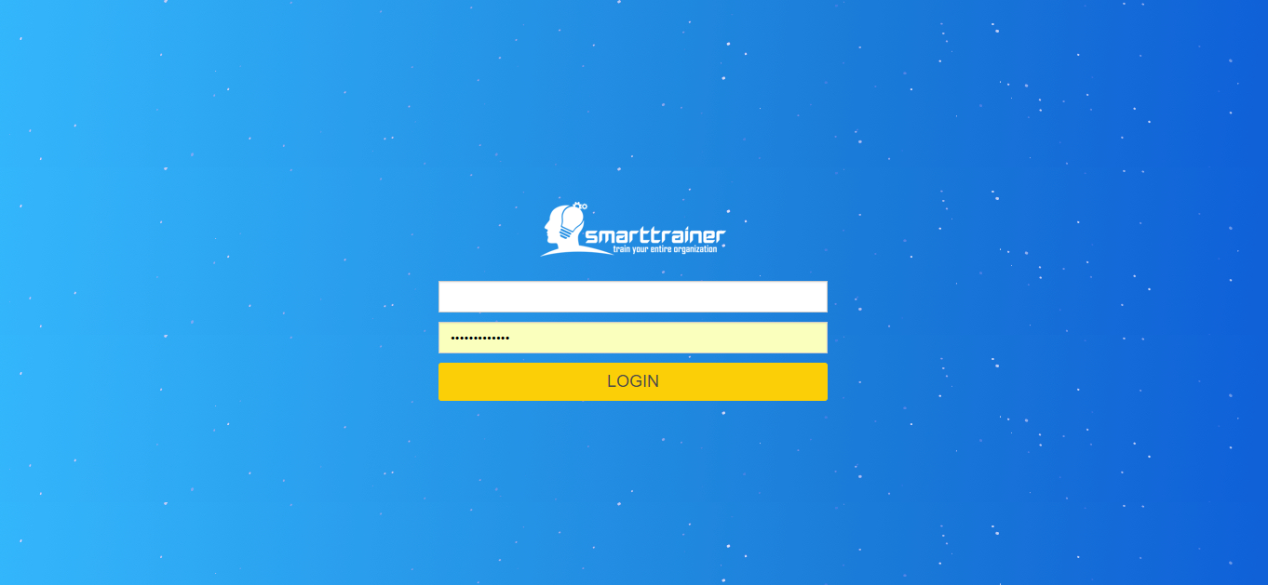

# How do I begin?

After login successfully, the Console will open to the Dealer Management module.

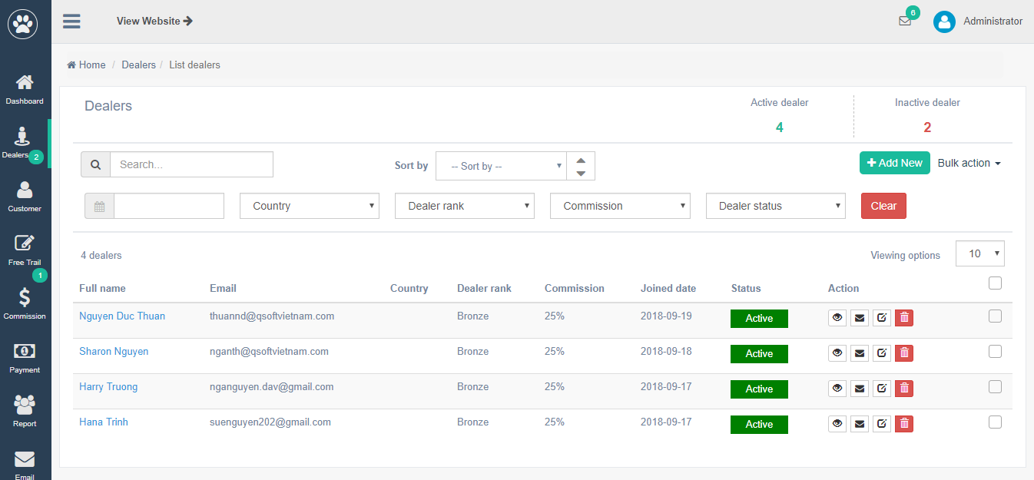

# How do I add a dealer to system?

In menu bar, you can simply click on **“Dealer”** module, then click on “**Add dealer”!**

After click on this button, you will be redirected to “Add dealer” screen:

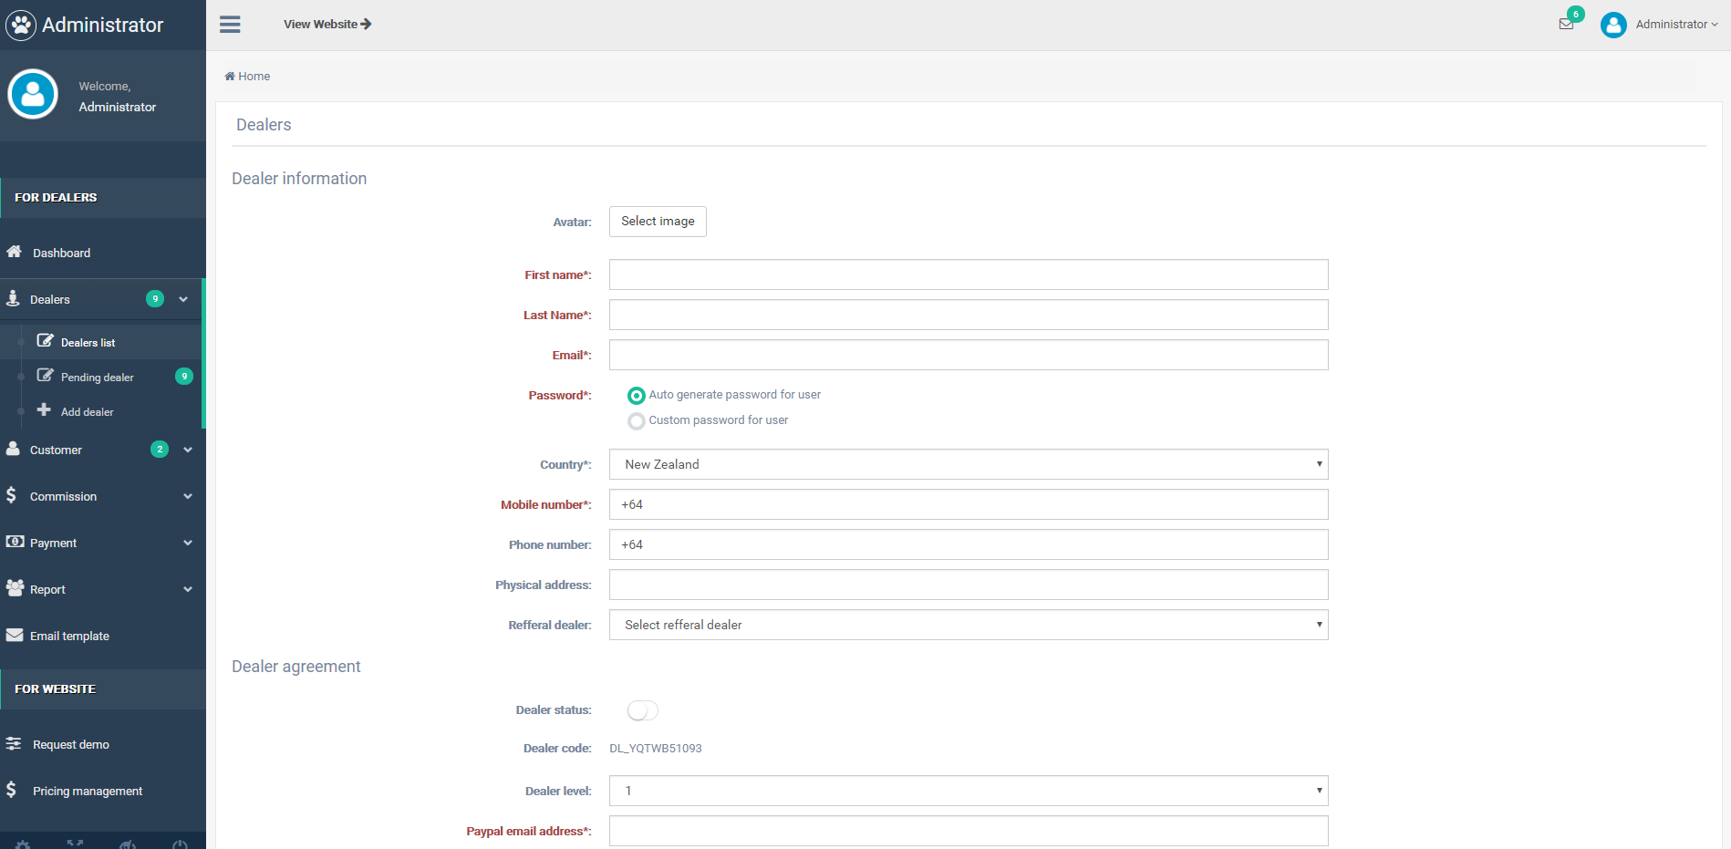

In order to add new dealer, you have to fill in 3 following sessions:

* **Dealer information:**

Dealer avatar: Optional field. Click on “Select image” to upload image from your computer.

First name: Required field.

Last name: Required field.

Email: Required field. Email must be include @, does not have space or special characters (^, &, *, $, #).

Password: Required field. You can select one of two options: Auto generate password for user, or Customize password for user.

Country: Required field. Select from dropdown list.

Phone number: Optional field. Validate based on country selected above.

Physical address: Optional field. Text input.

Referral dealer: Optional field. Select from dealer dropdown list.

* **Dealer Agreement:** Legal documents & unique code of dealer:

Dealer status: Auto set Inactive.

Dealer_code: Auto generated by system.

Dealer level: Level 1 or Level 2

*In Smart Trainer LMS Dealer System, we have 2 levels of dealer: Dealer Level 1 & Dealer Level 2*

* ***Dealer Level 1:*** *They are the same as the leader of a Dealer team. Dealer Level 1 can manage their subordinated dealers (change their commission rate for Courses, Plans, etc) or Add new dealer under their management*.*
* ***Dealer Level 2:*** *They are managed by Dealer Level 1. They also can add new dealer, but this new one will be automatically under the management of their Dealer Level 1.*

*\*They can earn extra money from difference in commission they set for Dealer Level 2 with the original one set for them.*

Paypal email address: Required field. Email must be include @, does not have space or special characters (^, &, *, $, #).

Dealer agreement: Required field. Legal documents which signed by Dealer.

* **Dealer rank & commission:**

Dealer rank: Required field. New created dealer will be auto set as lowest rank*

*\*Ranking is based on dealer sales.*

Dealer commission: Auto set maximum commission for this dealer rank. Dealer can not change this commission higher than the original setting.

Dealer discount amount: Set discount amount for customers when they buy courses from Smart Trainer LMS.

# How do I manage my dealers?

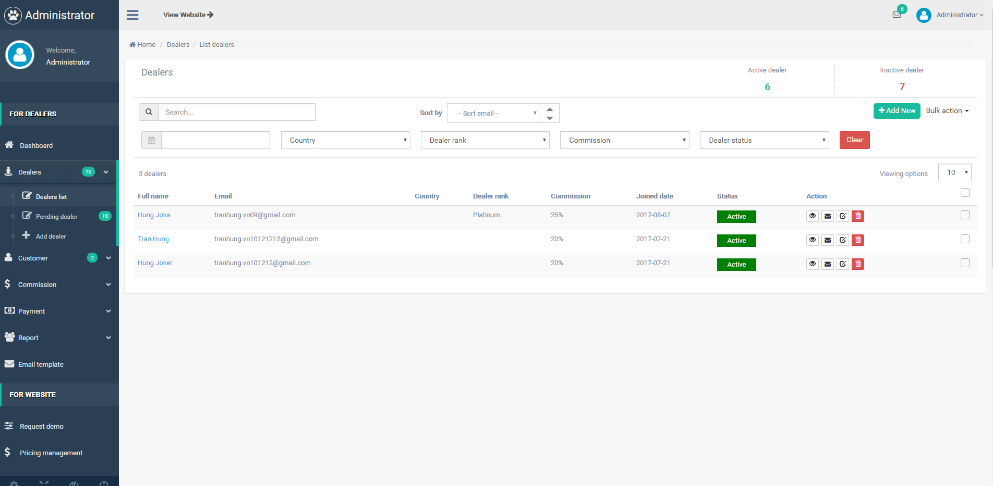

In dealer list, you can easy search, sort or filter to find the dealer who you want to view:

**Search free text**

**Sort by:** Full name; Email; Country; Dealer rank; Commission; Join date

**Filter by:** Dealer join date; Country; Dealer rank; Commission; Dealer status; Clear filter

In Dealer management list, you can view detail dealer information, edit their info, delete dealers or send email to them.

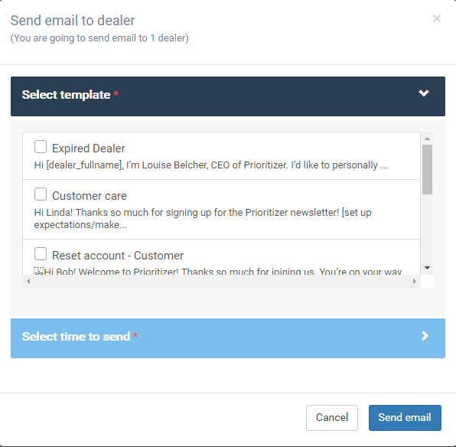

# How do I add my new customers?

Just like add new dealer to system, you can add new customer from menu bar, select “Customer” module, then select “Add customer” sub-module:

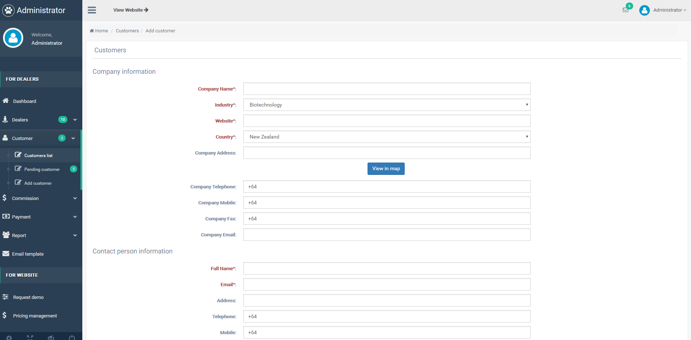

In order to add new dealer, you have to fill in 3 following sessions:

* **Company information:**

Company name: Required field. Text input.

Industry: Required field. Select from dropdown list.

Website: Required field. Text input.

Country: Required field. Select from dropdown list.

Company address: Optional field. You can view in Google map this address.

Company telephone: Optional field. Verified based on country field selected above.

Company mobile: Optional field. Verified based on country field selected above.

Company fax: Optional field. Verified based on country field selected above.

Company email: Optional field. Email must be include @, does not have space or special characters (^, &, *, $, #).

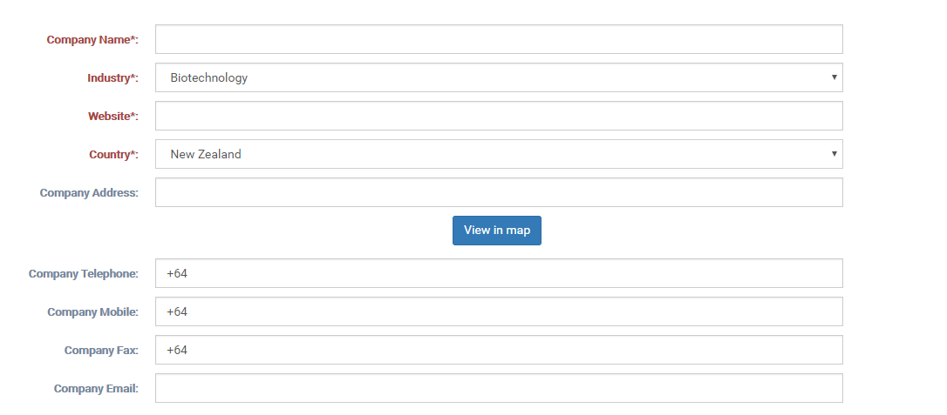

* **Contact person information:**

Full name: Required field. Input text.

Email: Required field. Email must be include @, does not have space or special characters (^, &, *, $, #).

Address: Optional field. Text input.

Telephone: Optional field. Verified by country field selected above.

Mobile: Optional field. Verified by country field selected above.

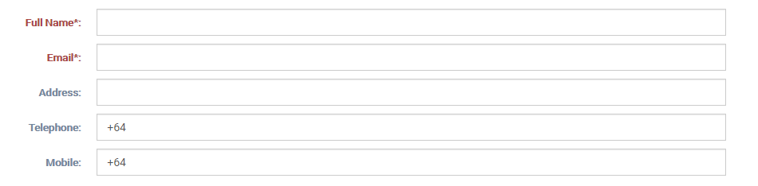

* **Sub domain details**

Admin link: Optional field. Input text.

Trainee link: Optional field. Input text.

Type of customer: Select from dropdown list: Trial/ demo version; Official plan (Monthly); Official plan (Yearly)

Domain cost: View domain cost. This will be auto link with customer’s selected plan.

Payment status: Paid or Not paid.

Available from: select start date and end date.

Status: Required field. Auto set Inactive.

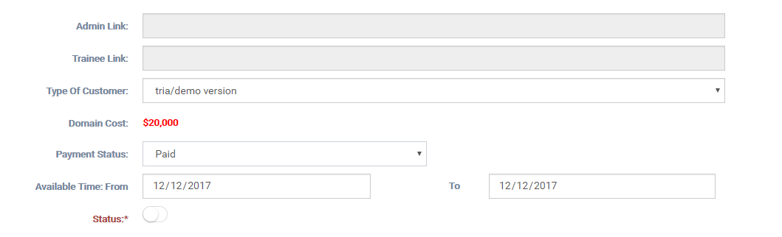

# How do I manage all my customers?

All customers will be showed in “Customers list” module. In Customers list, you can easy search, sort or filter to find the customer who you want to view:

**Search free text**

**Sort by:** Company name; Customer type; Industry; Expired date; Dealer.

**Filter by:** Customer type; Country; Industry; Dealer; Status; Clear filter.

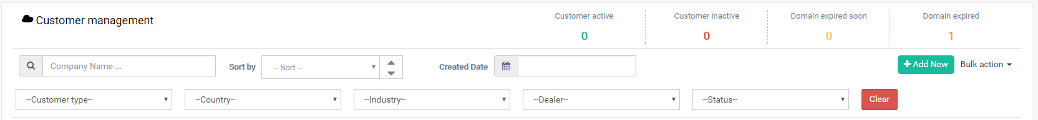

In Customers management list, you can view detail customer information, edit their info, delete customers or send email to them.

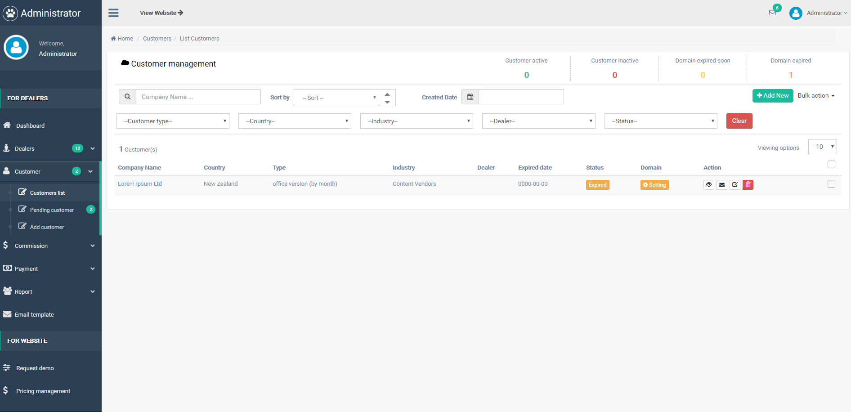

*\*Note: For customers who signed up from website & have no dealer taken care off, admin can assign this customer to any dealer to take care. After assigning, dealer will receive an email to notify about it.*

# How can I view commissions?

You can recheck all your commissions which you earned in **“Commissions management”** module. Search by Dealer full name; Sort by Dealer full name, Sale amount, Commission, Dealer earning, Created date; Filter by Commission created time, Product type or Status.

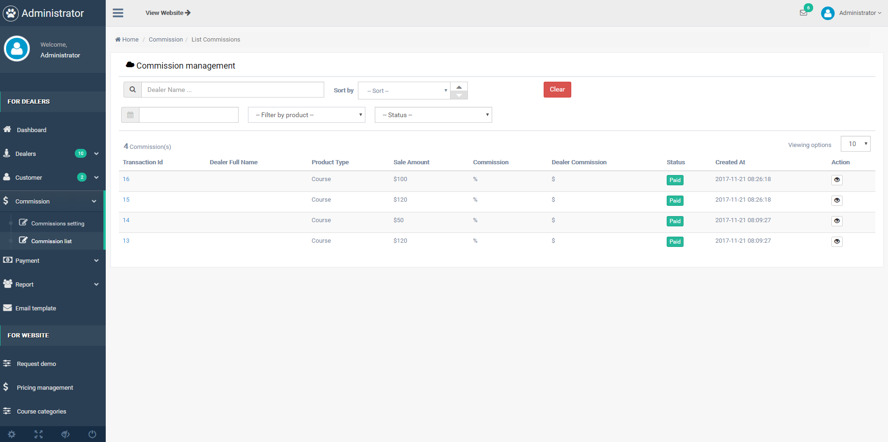

# How can I view my payment history?

You can follow your payment history which paid by Smart Trainer admin in **“Payment history”** module. Search free text; Sort by Amount, Fee or Payout date; Filter by payment time.

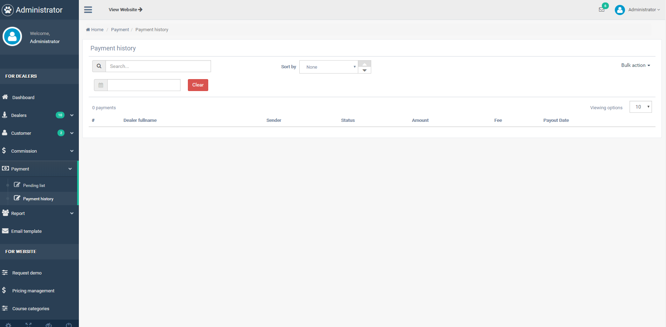

# How can I request to withdraw money from Smart Trainer?

You only can request to withdraw money after you reach more than $100 commission. After you send request to withdraw money, admin will go to Console then make payment via PayPal to you.

You will receive money with your PayPal email. So please remember to check this PayPal email carefully when you signed up!

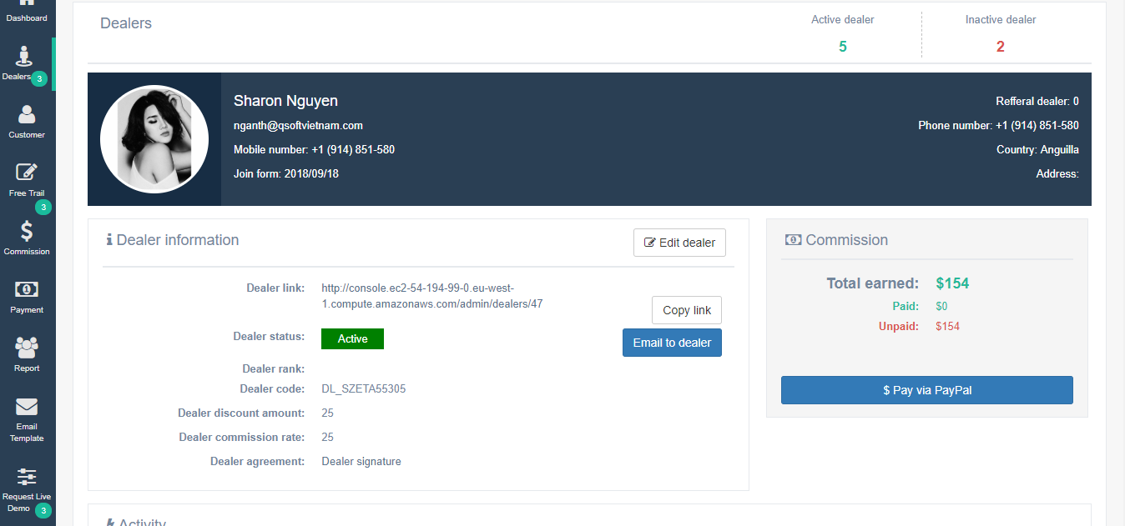

You can send request to withdraw in your detail page. After you get at least $100, button “Withdraw money” will be enable.

# How can I upload course to system?

Smart Trainer LMS Console is followed SCORM version 2004. So when you want to create new course, it have to obey SCORM 2004.

**Step 1:** Go to **“Generate Courses”** sub-module in **“Generate”** Module

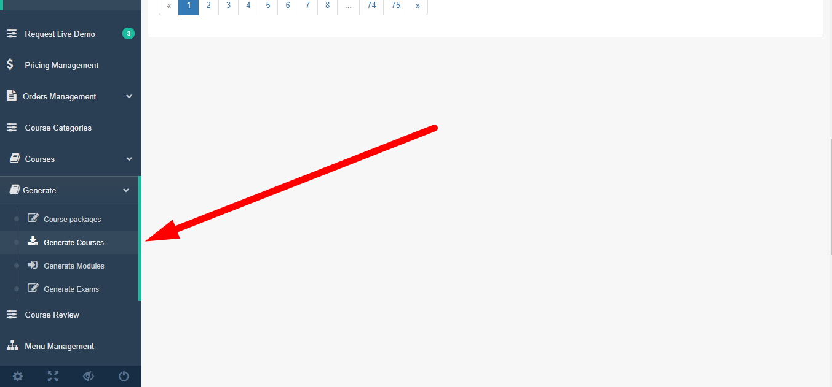

**Step 2:** Click button “Add new” to add new course information:

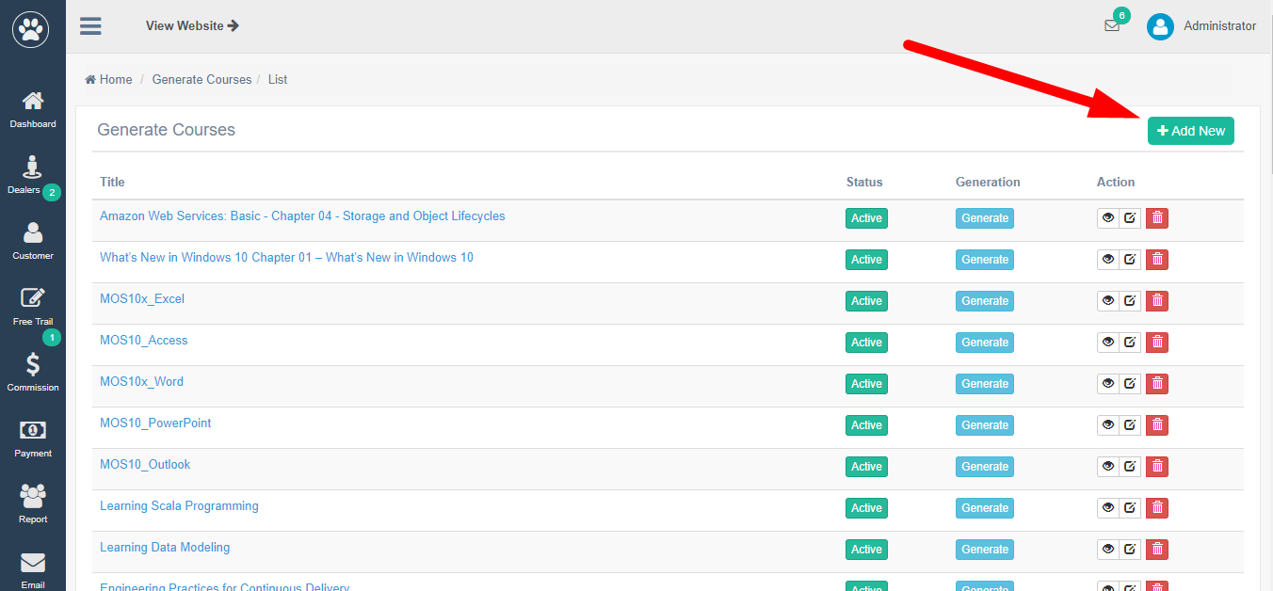

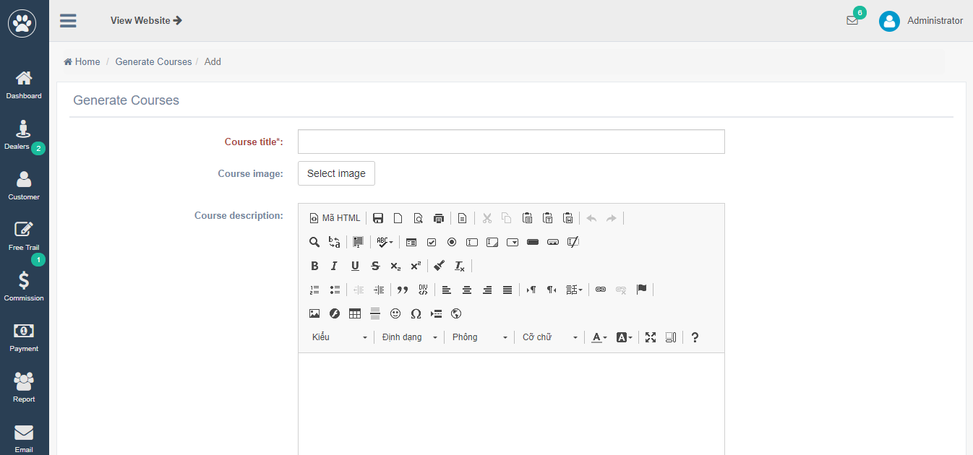

**Step 3:** After you create course successfully, let’s go to sub-module **“Generate Modules”** to continue create modules in course:

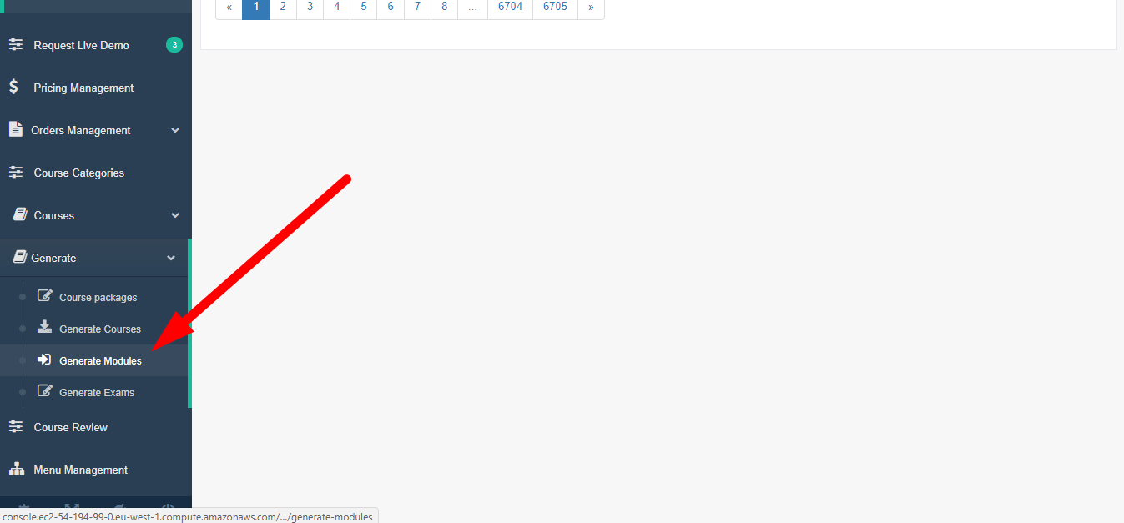

Click button “Add new” to add new module:

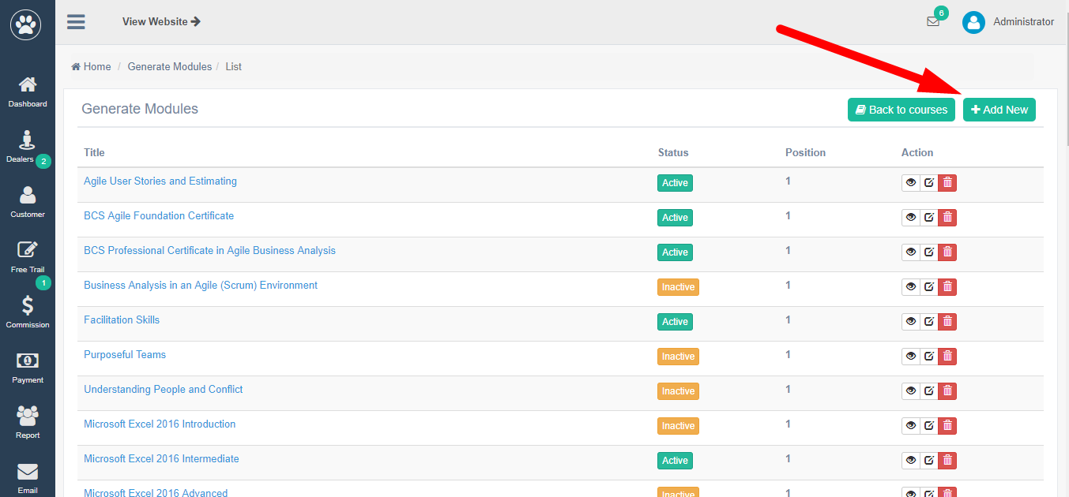

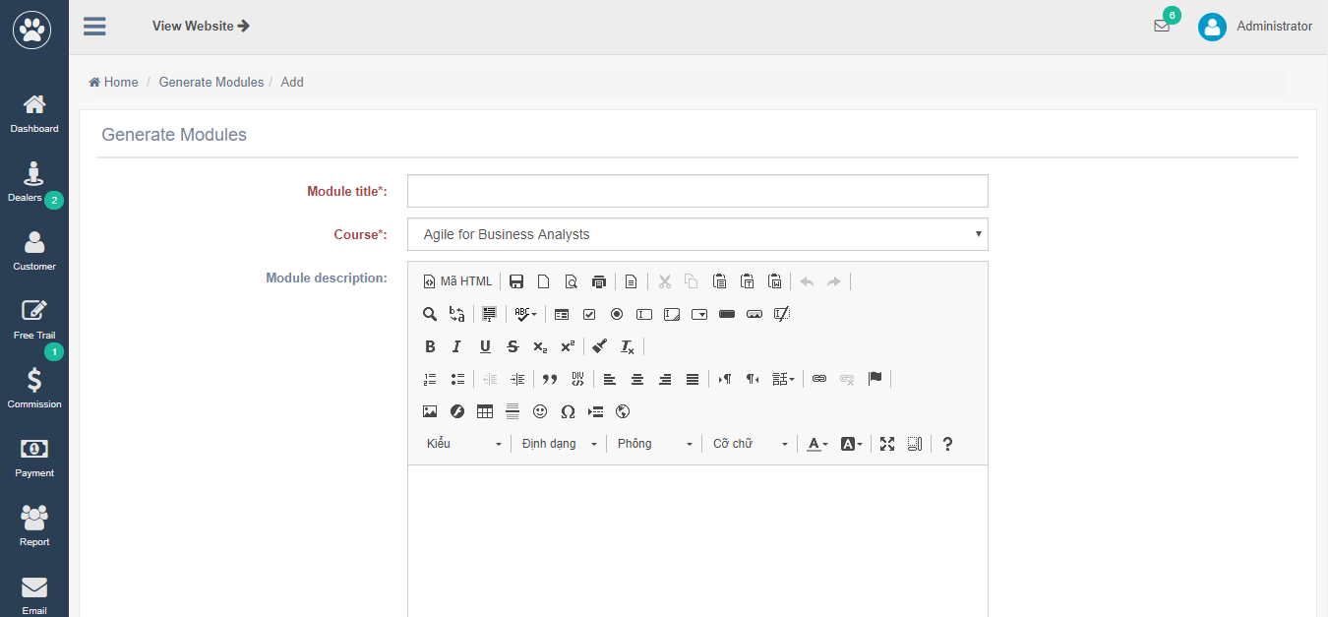

**Step 4:** If you want to add exam to course, continue go to sub module “Generate Exam”

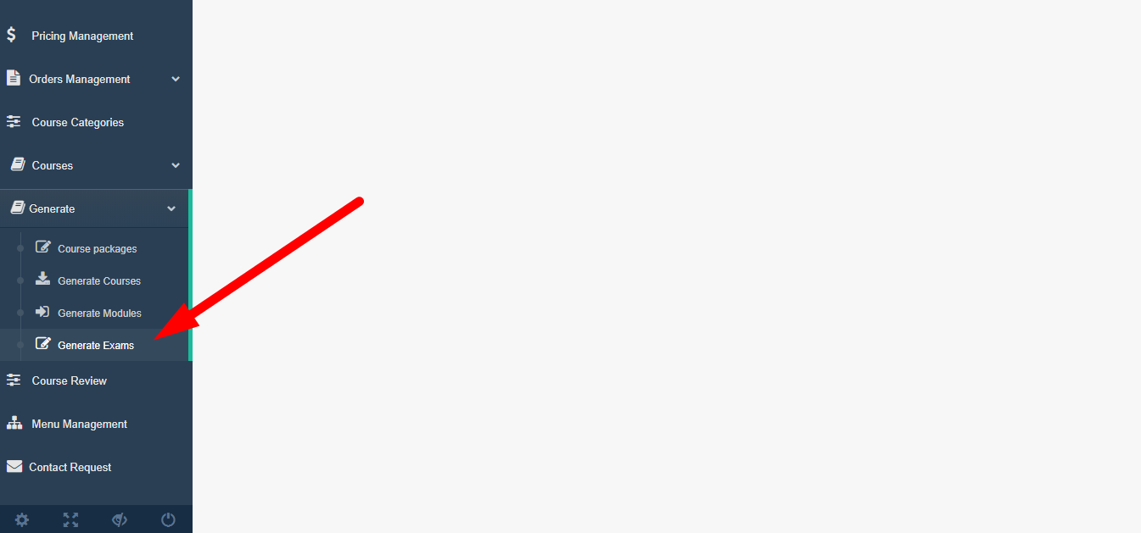

Click button “Add new” to create new exam to course:

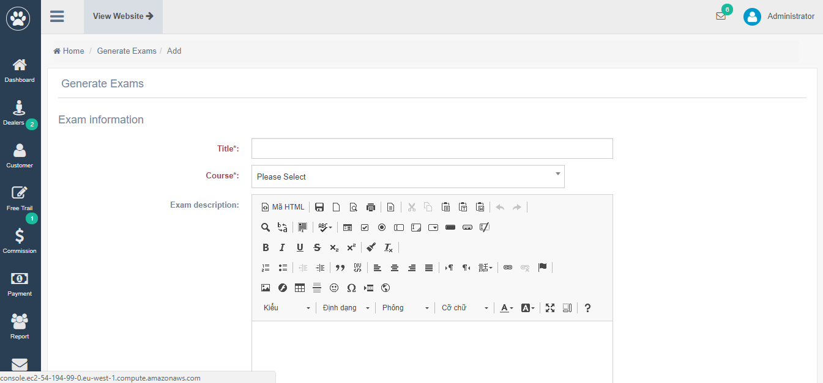

**Step 5**: After you already create course information, add modules to course, add exam to course, now, you can Generate course to SCORM package:

Turn back to sub module **“Generate Courses”**, click button “Generate”:

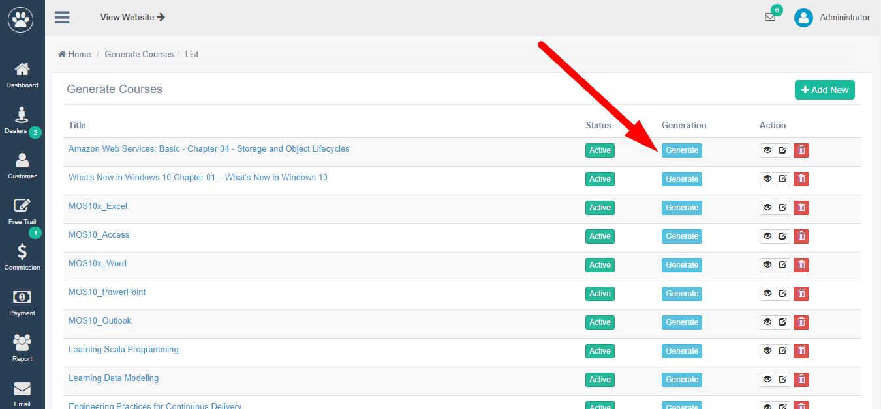

After you generate course successfully, all course generated will be showed in sub-module **“Course packages”**

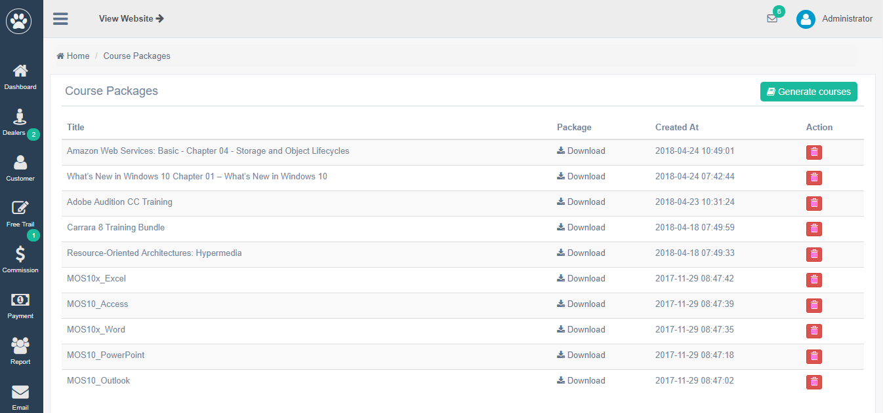

These course packages are .zip file, which will be sent to your customer via email after they make payment successfully or import directly to admin system (only Free courses can be imported by this way).

**Step 6:** In order to create a course then public it on the website, go to **“Courses”** module > **“Courses list”** sub-module:

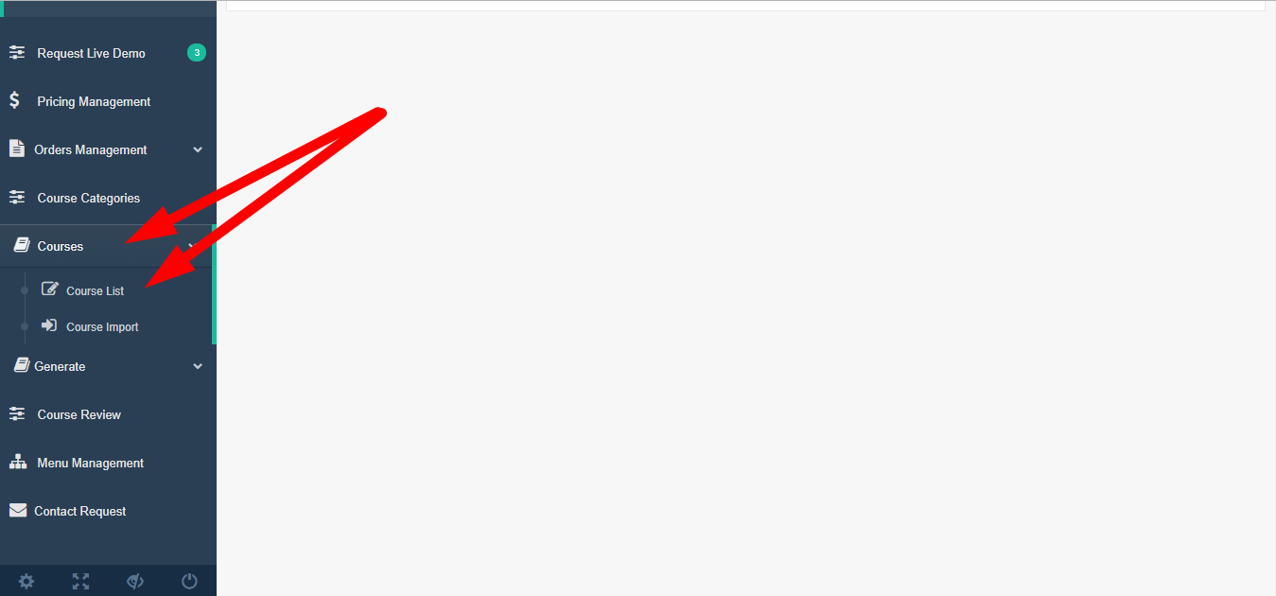

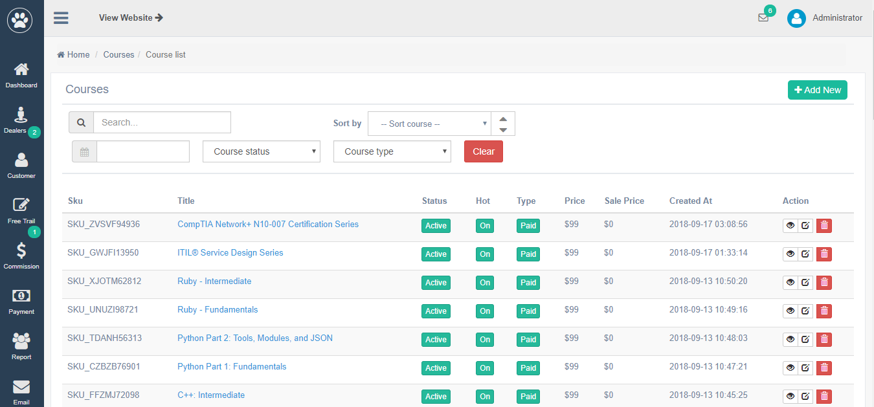

*\*Note: Especially for courses from Career Academy, you can import file .zip via sub-module* ***“Course Import”:***

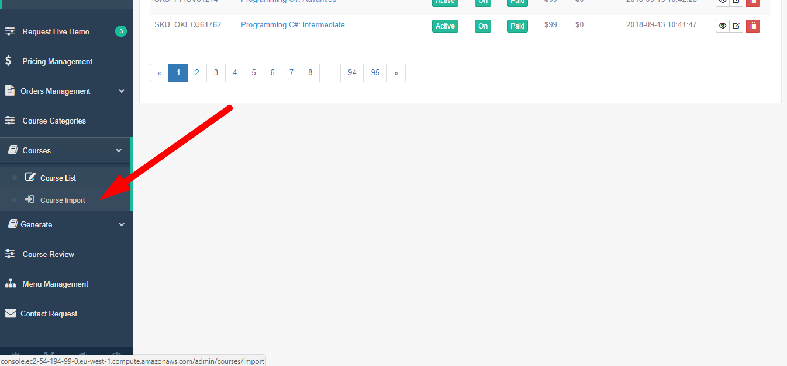

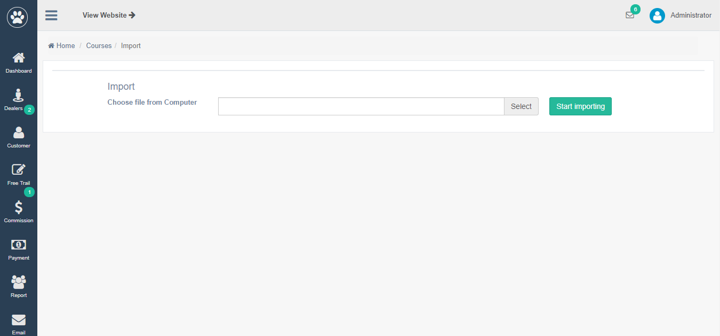

By this way, course also can be imported to system then generate into a package. And it will be managed in module **“Course packages”:**

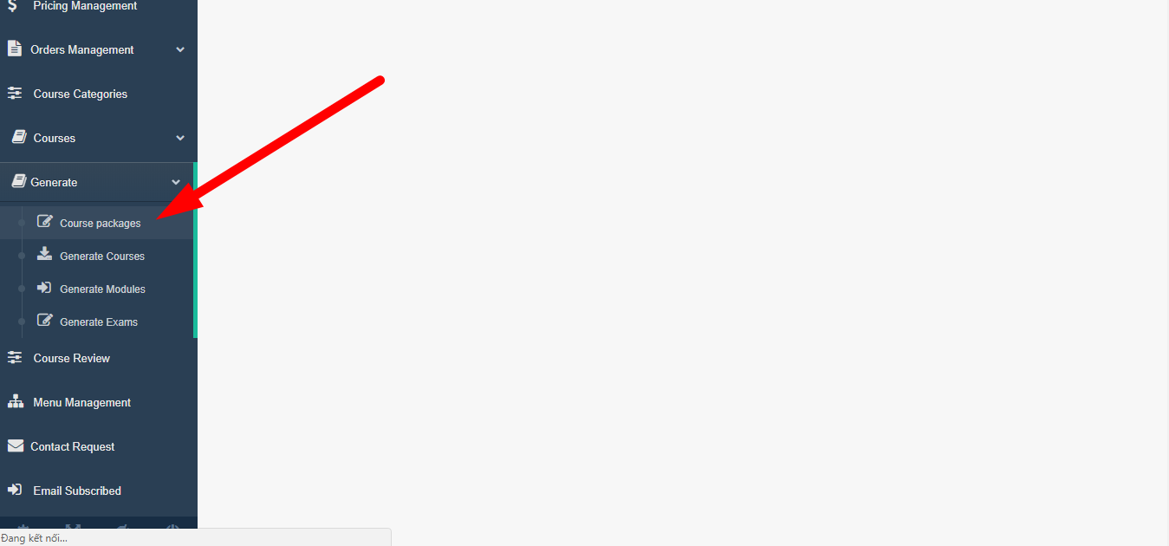

# How can embed signed up form into my own website?

You can embed 4 signed up form into your own website:

* Buy membership form

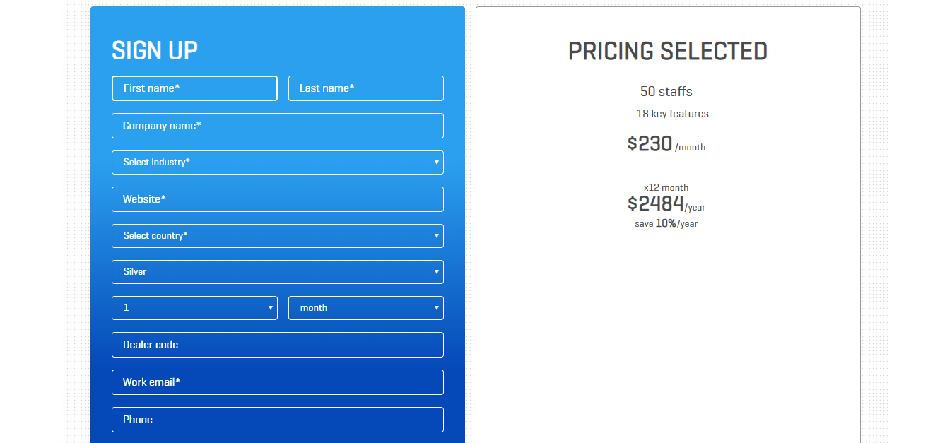

* Request for Free Trial form

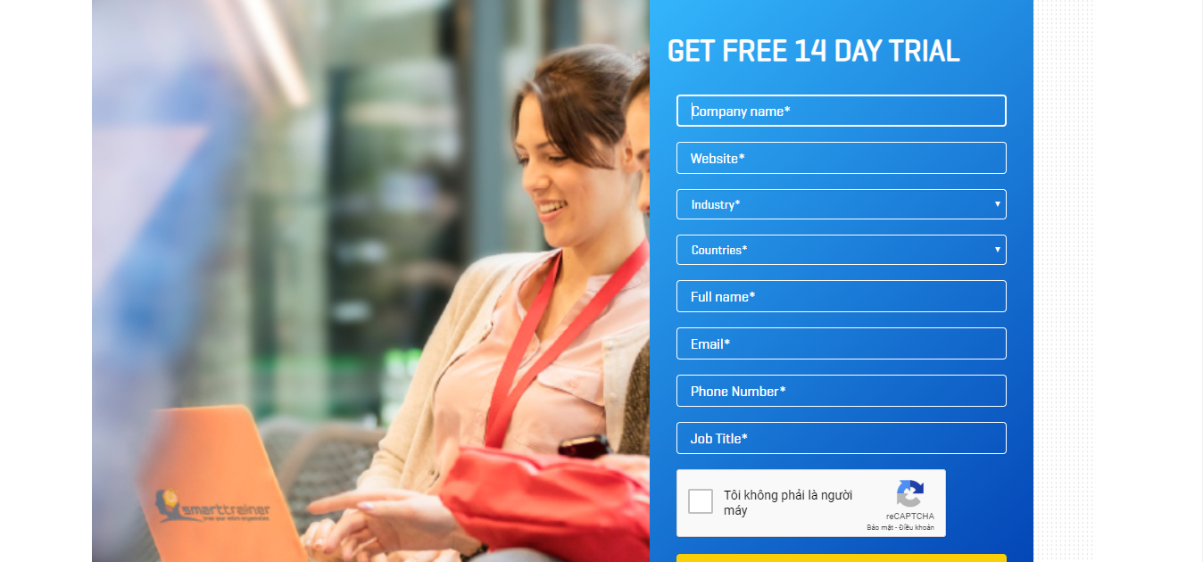

* Become a Dealer form

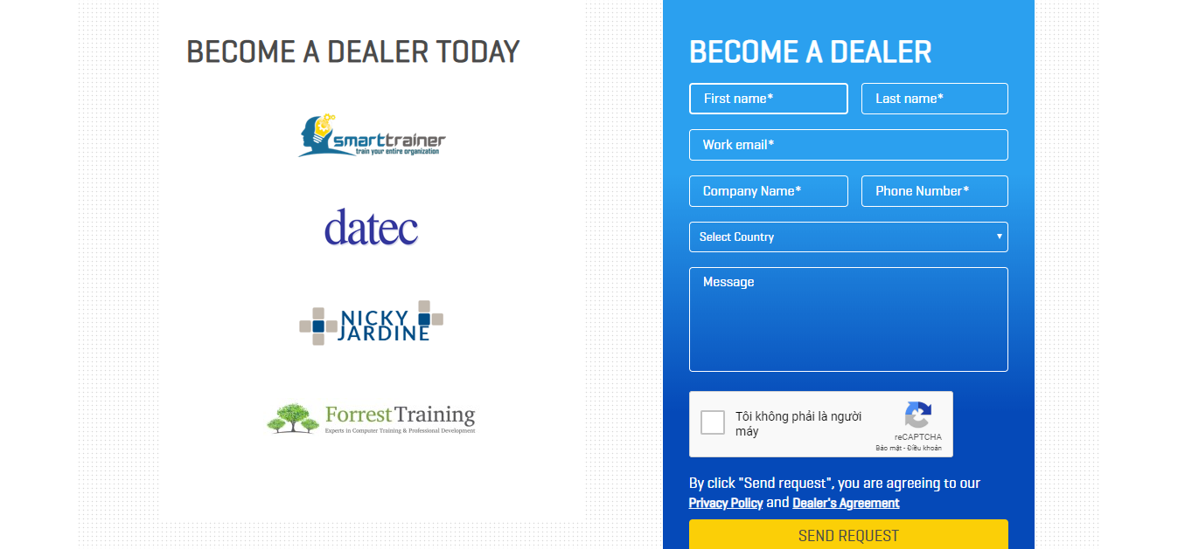

* Request for Live Demo form

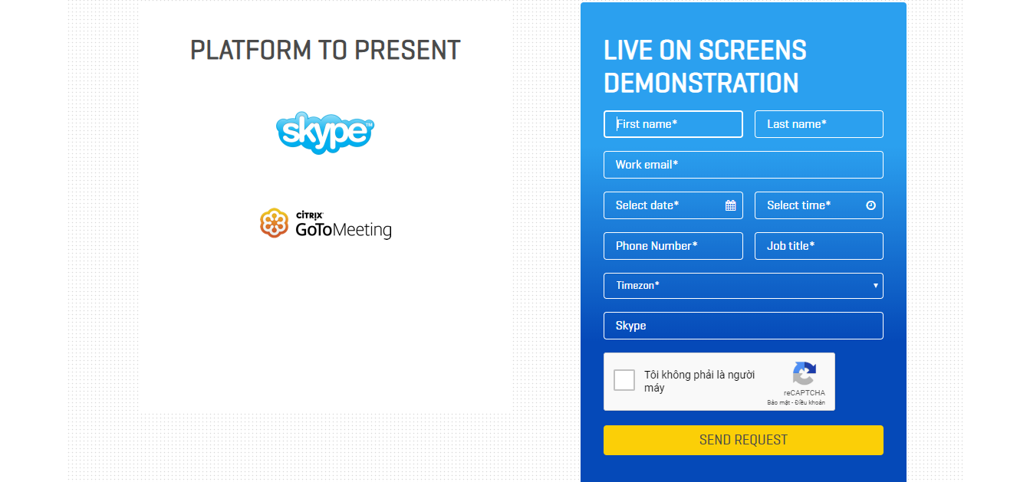

© Smart Trainer LMS

280 Great South Rd, Greenlane, Auckland 1051, New Zealand