Smart Trainer LMS

User Manual Guide
For Trainees
July 5, 2018


Welcome to Smart Trainer LMS!
Smart Trainer allows the online delivery of training with real time tracking of training results, optimizing time and reducing cost associated with traditional learning methods. Smart Trainer is a learning software designed to deliver, track, train and certify online training.

Table of Contents

Welcome to Smart Trainer LMS! 0
Table of Contents 1
How to access to the LMS? 3
What do I do to begin training? 3
How do I access to my single course training? 4
How do I access to my training plan? 5
How do I begin my training? 6
How do I access my ILT Training? 7
How do I manage all of my certificate? 9
How do I manage my exam attempts ? 11
How do I view my department/ location information ? 13
Can I request a course for my whole department ? 14
Can I create my own reminder? 17
Can I view my bookmarks? 19
Can I change my account information? 20

How to access to the LMS?
Step 1: Go to Smart Trainer LMS Online Training site.
Step 2: Enter your login in the Email field.
*Email must be include @, does not have space or special characters (^, &, *, $, #).
Step 3: Enter your Password.
Step 4: Click on the “Login” button.
*Click on “Remember me” check-box to save password for the next login.
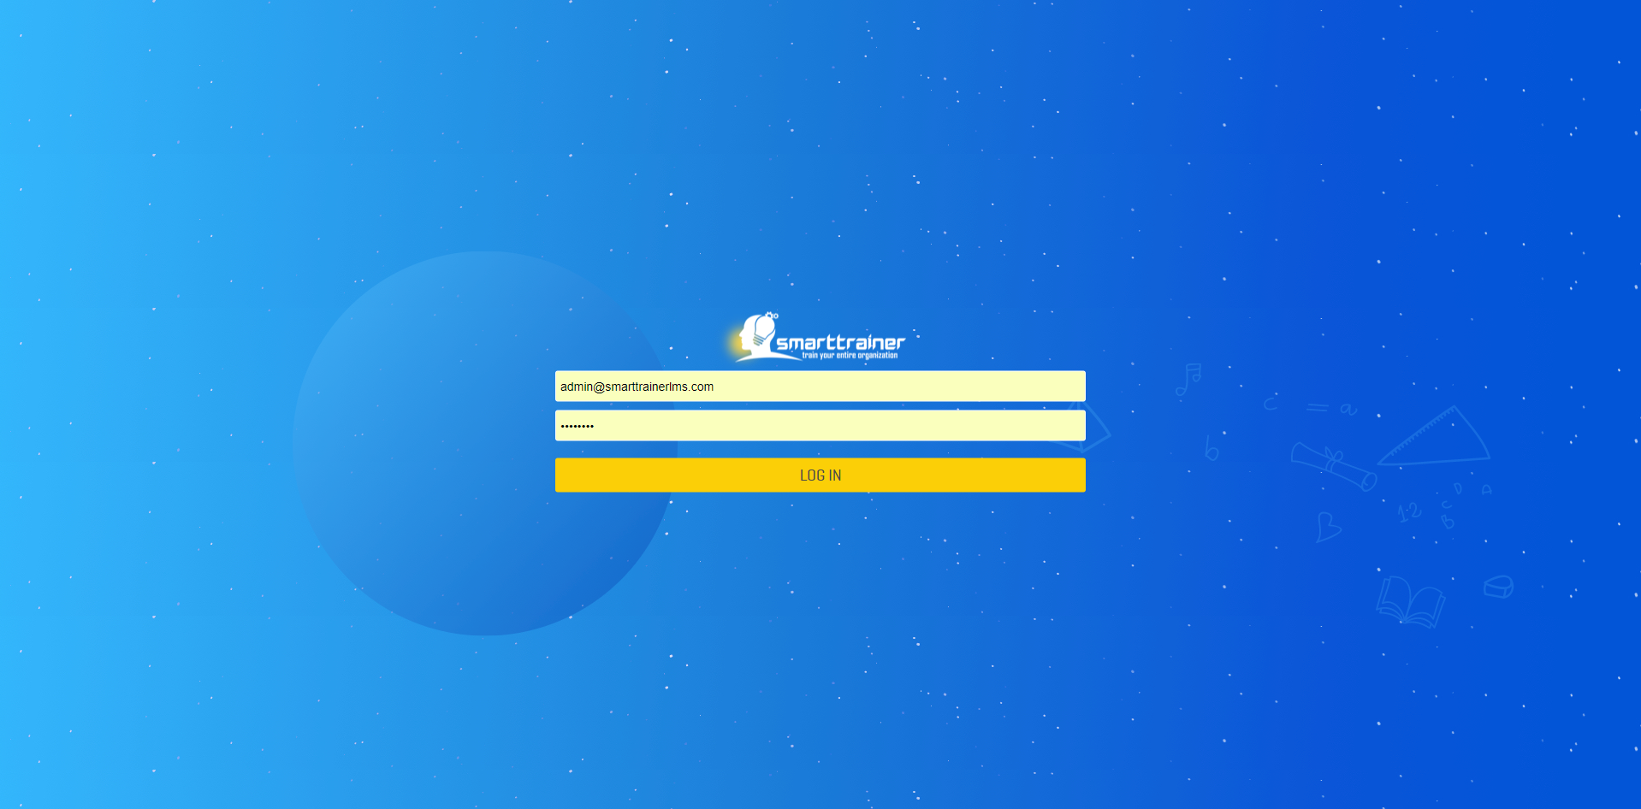

What do I do to begin training?
Smart Trainer LMS has 2 types of training: Single course, which trainees have to learn the whole course, take exam & get certificate to complete course training; Training plan, which trainees have to learn multiple modules from multiple courses, take exam & get certificate to complete training plan.
After login successfully, the LMS will open to the Dashboard screen.
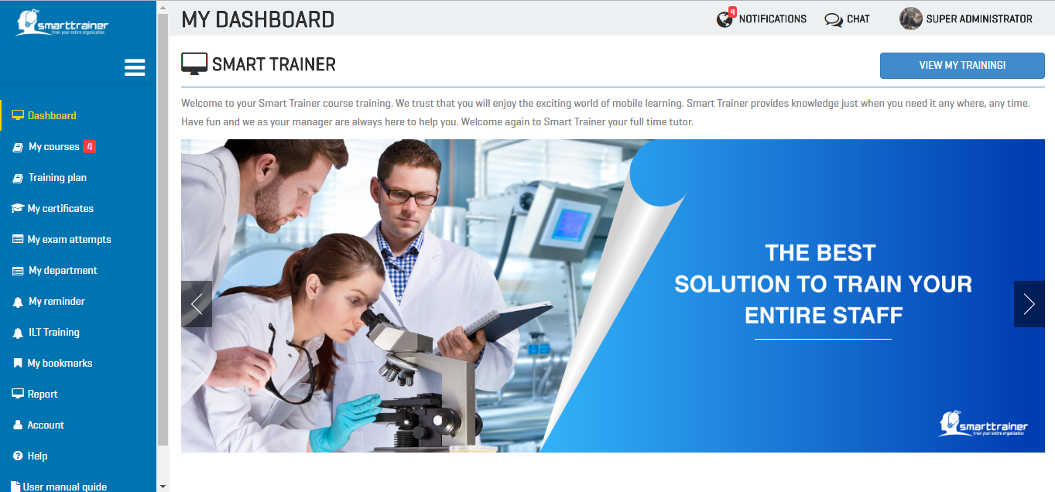

How do I access to my single course training?
In Dashboard, you can simply click on “Start training!” to begin training.
After click on this button, you will be redirected to “My course” module, which show all single courses available to you.
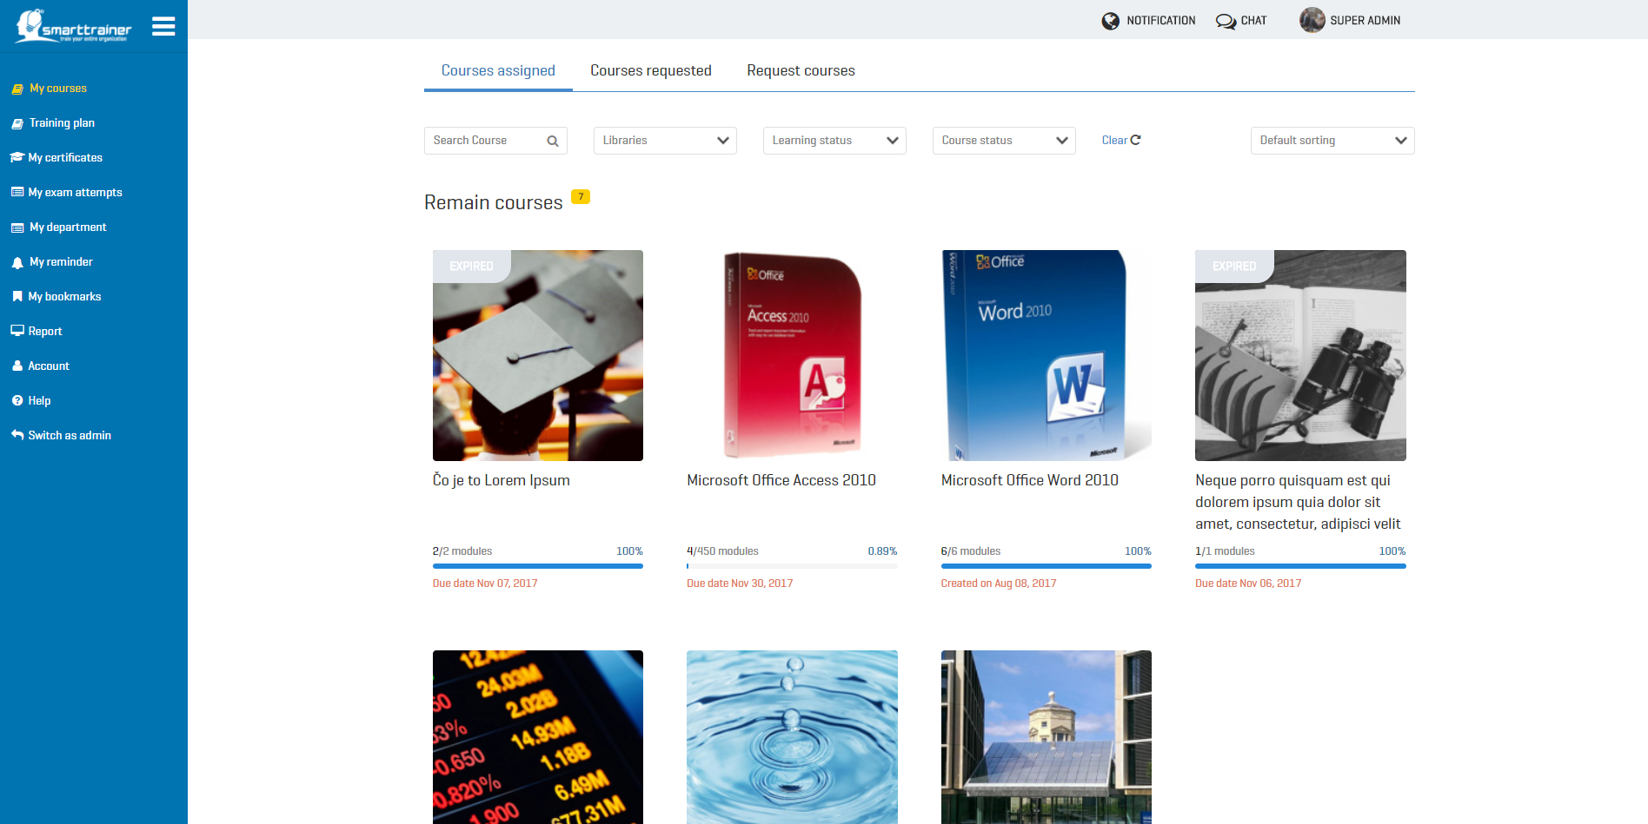
In this screen, you will see all the courses are divided into 3 main tabs:
- Courses assigned tab: All courses which are assigned to you by the system administrator or your Department’s manager.
- Courses requested: All courses which you requested to take learning.
- Request courses: All courses which are available to you. You can send request to join these courses at any time you want.

How do I access to my training plan?
In order to access to your training plan, let’s click on “Training plan” module in the side bar menu.
In this screen, you will see all the training plans divided into 3 main tabs:
- Training plan assigned: All training plan which are assigned to you by the system administrator.
- Completed: All training plans which you already completed.
- Expired: All training plans which were expired to you. You cannot no longer take any action on it.
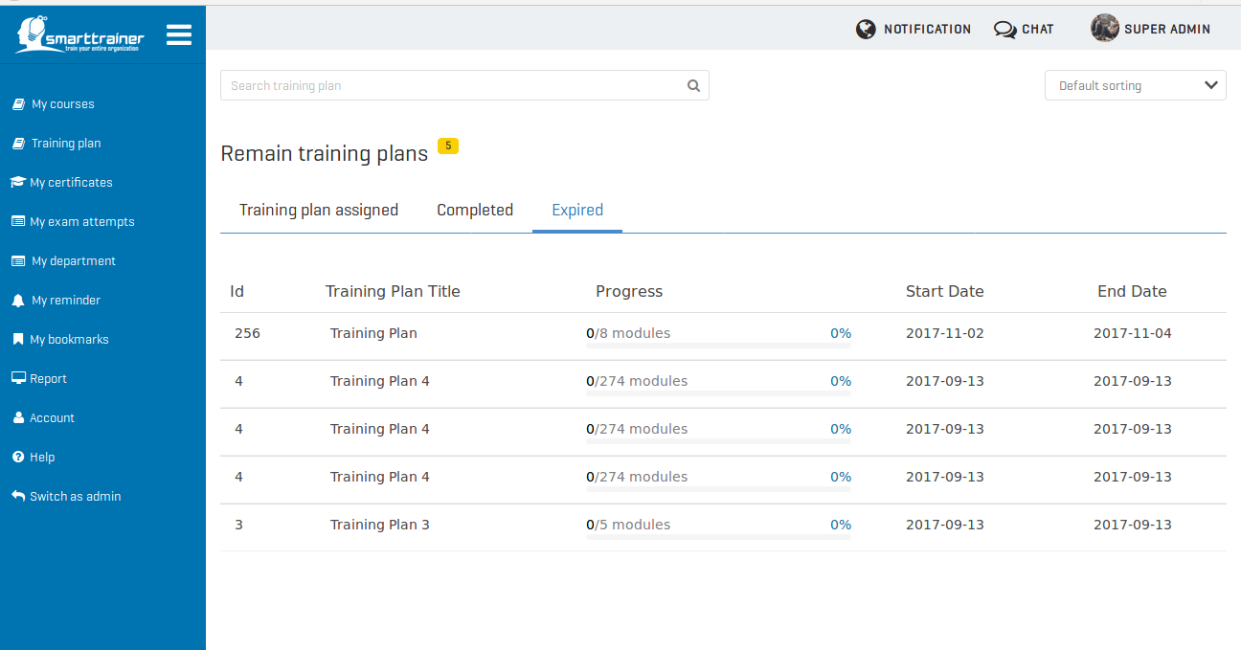

How do I begin my training?
You want to start learning course or training plan? It’s easy.
Just click on the “Start training” button 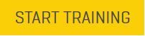 in the course list or training plan list. Then, you will be redirected to training screen.
Let’s start & enjoy your training!
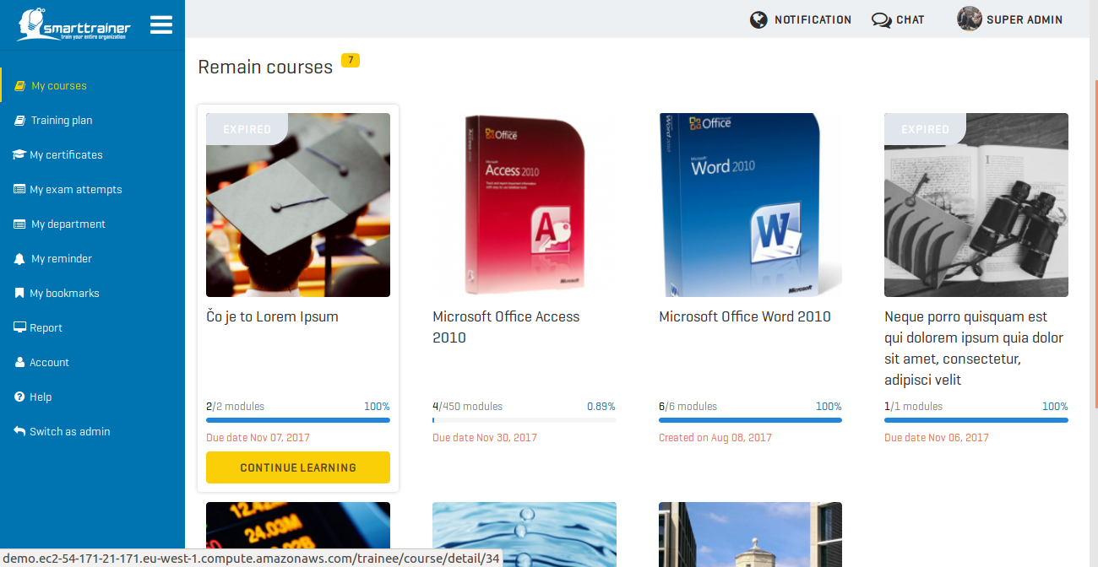

How do I access my ILT Training?
All of your ILT trainings will be shown in “My ILT Training” module.
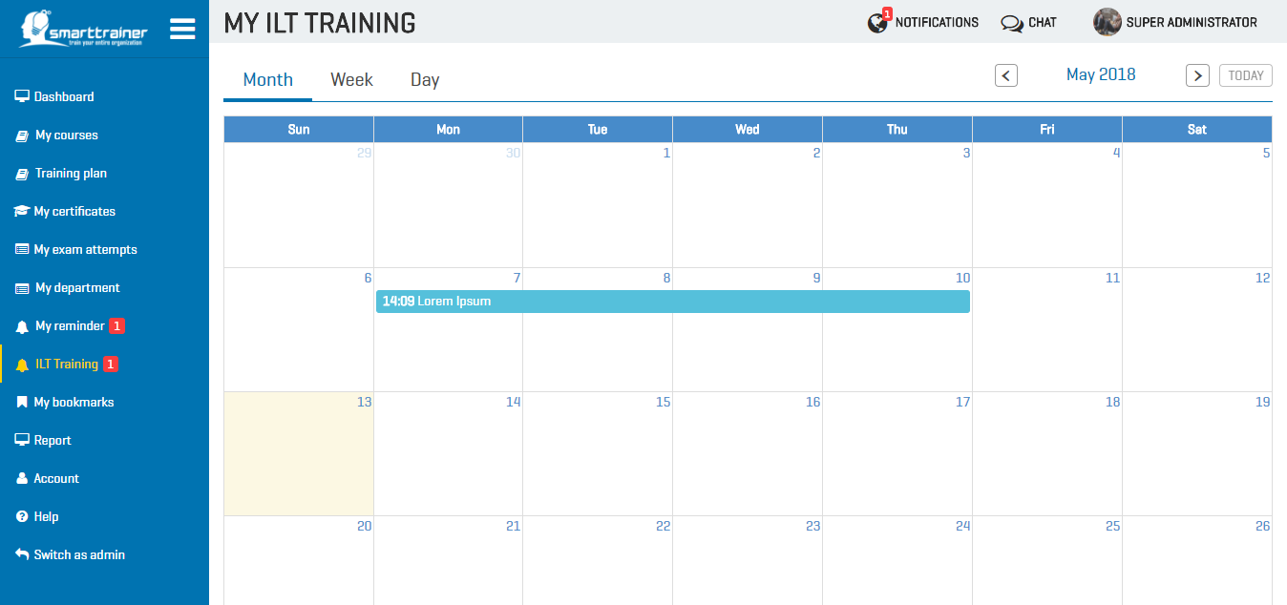
You can view it on calendar or click to view detail:
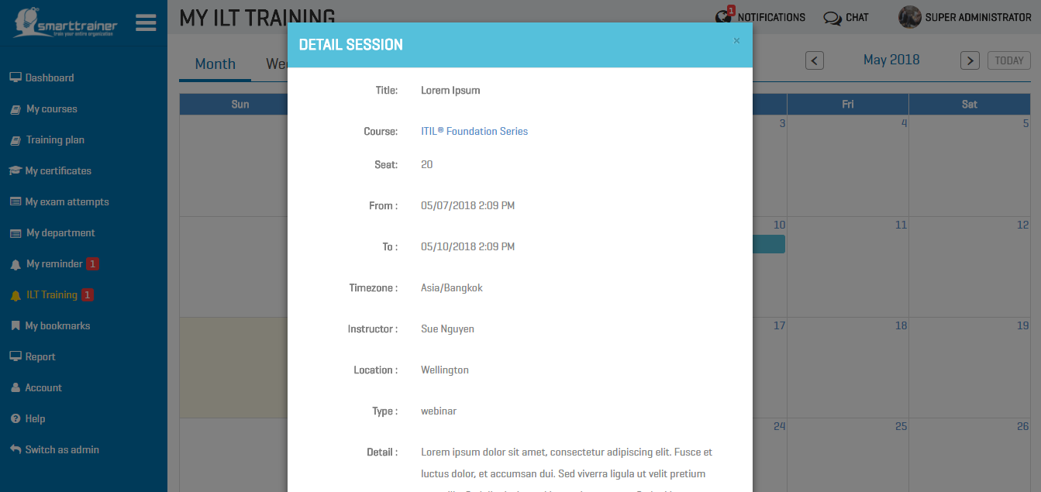
- ILT training session title
- Course or training plan related to this ILT training
- Total number of seat available
- Duration: Start date - End date
- Timezone
- Instructor
- Location
- ILT training type: Webinar or Classroom
- Other detail information for this ILT training session

How do I manage all of my certificate?
All of your certificates will be saved in “My certificates” module.
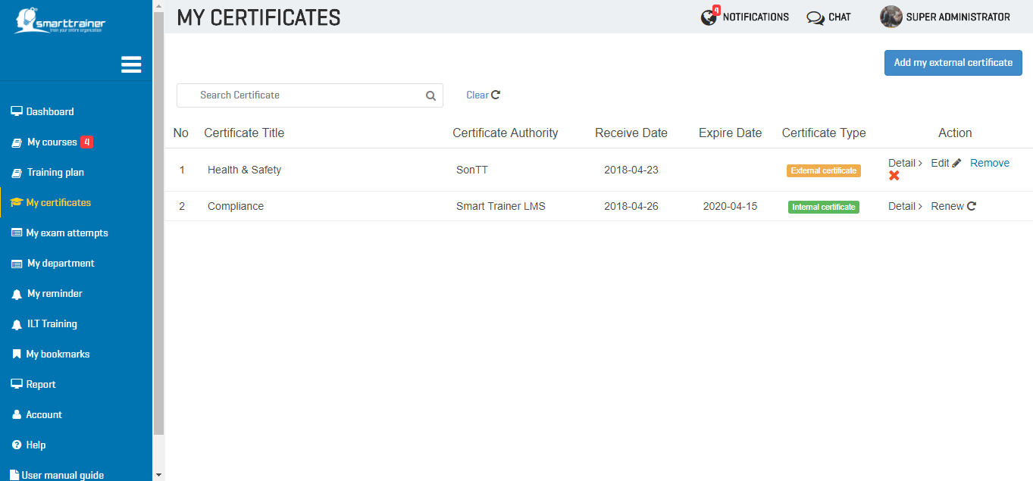
At your certificates list, you can view detail certificate or renew it when it is expired.
On the other hand, you also can add your external certificate by click on button “Add my external certificate” 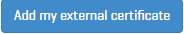
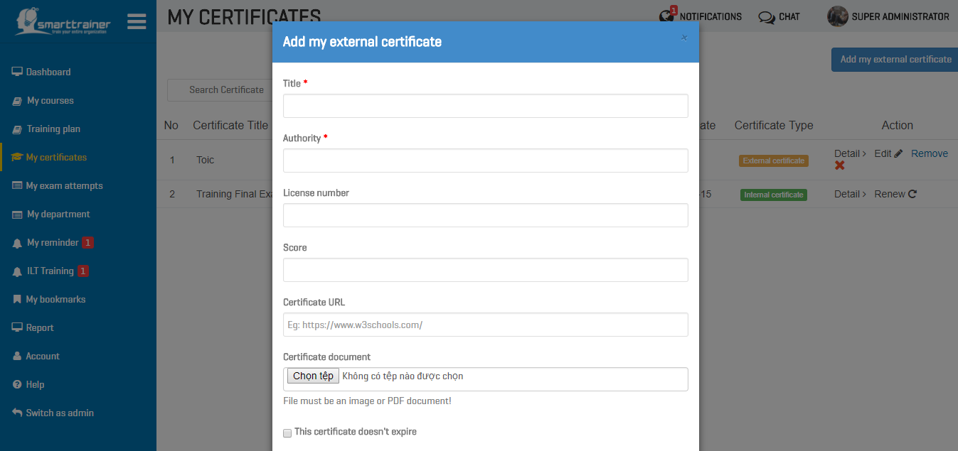
You can add existing certificates gained from outside sources, so HR can view your achievements!

How do I manage my exam attempts ?
You can manage all your exam attempts in “My exam attempts” module.
In this screen, you can see all your exam attempts by courses. Search to find your course or click on “View” to go to detail exam attempts:
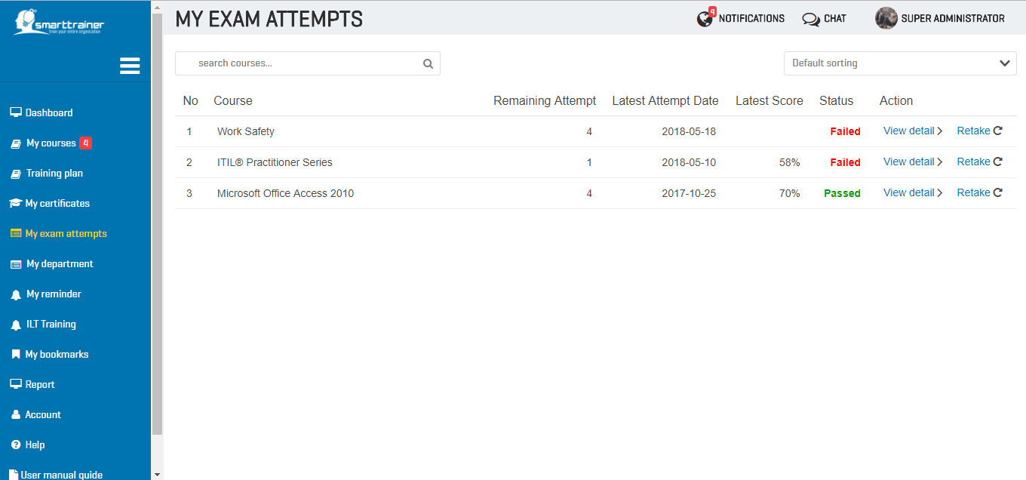
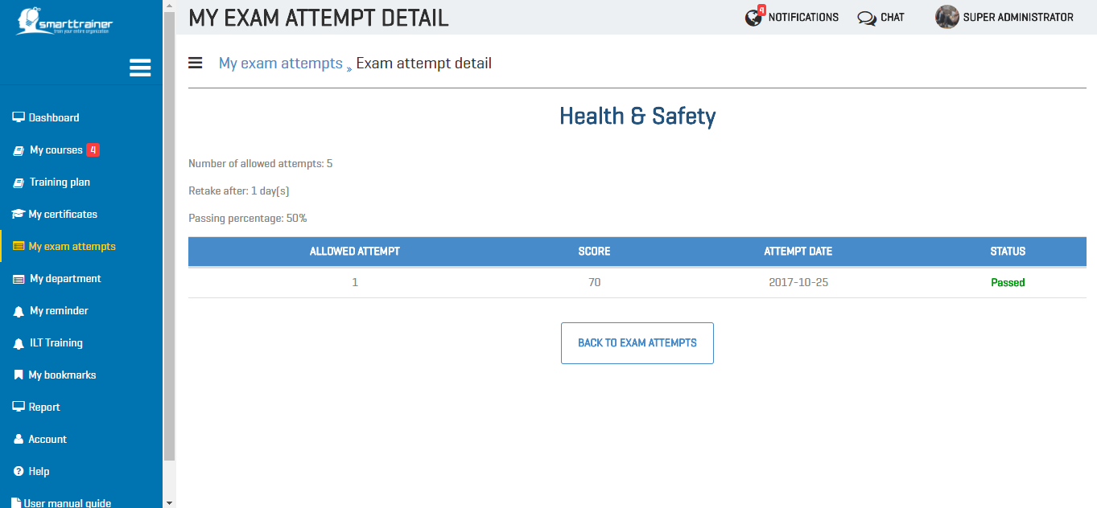
When viewing exam attempt detail, you can decide whether retake the course or back to view all exam attempts.

How do I view my department/ location information ?
If you are belong to a department or location, you can view your department/ location information in “My department” module.
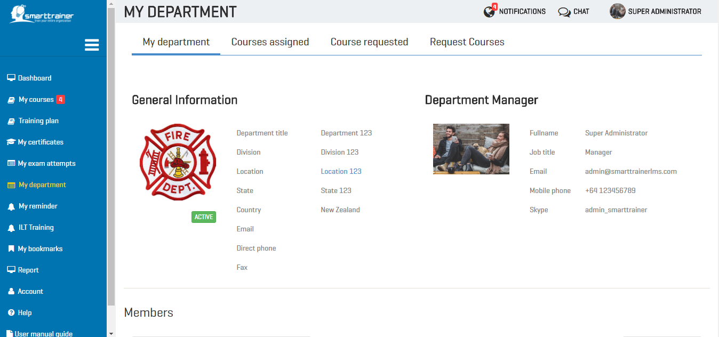
In this screen, you can view your department’s general information, such as:
- Department logo
- Department title
- Location of your department
- Department’s email
- Department’s direct phone
- Department’s fax
On the right side, you also can see your department’s manager information:
- His/ her full-name
- Job title
- Your manager email
- Your manager mobile phone
- Your manager skype
And do you want to search or view members in your department? If yes, let’s scroll down to view Members list in your department!
From the members list, you can view other member information or chat with them.
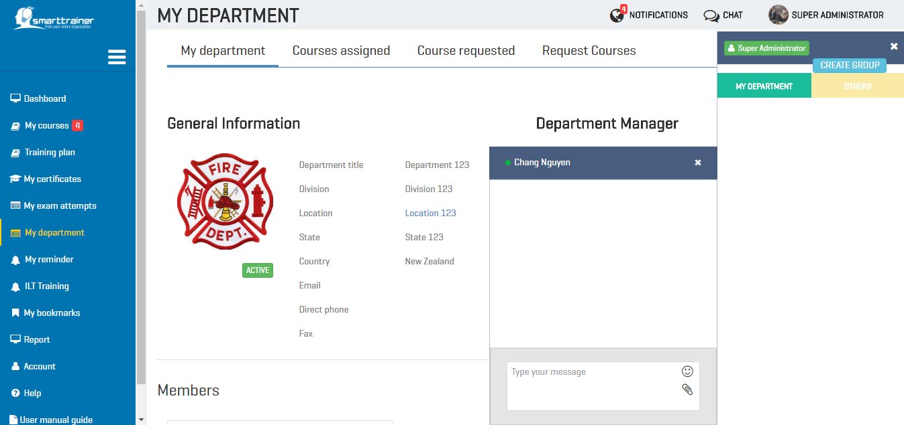

Can I request a course for my whole department?
Absolutely yes! If you are department’s manager, you can select courses in tab “All courses” to send request for your whole department or only some members.
Click on “All course”, select course then click “Send request”!
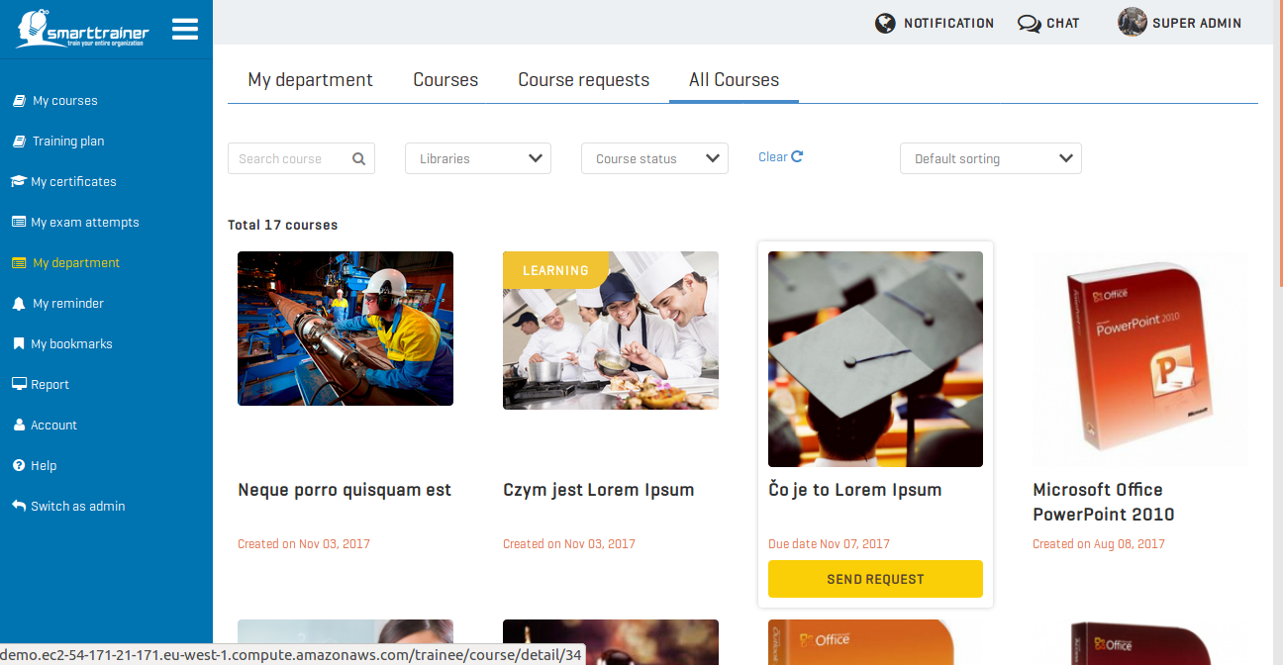
After click on “Send request”, if you want to request for your whole department, just click on “Send” button. On the other hand, if you only want to request for some of department, you can select them then click “Send”.
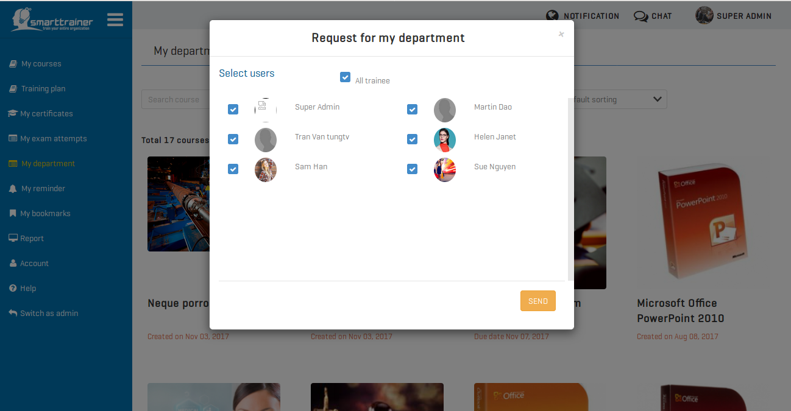
The system administrator will receive your request right after you click “Send” request.
Until they accept, reject or on-hold your request, you will see a real-time notification about this action!
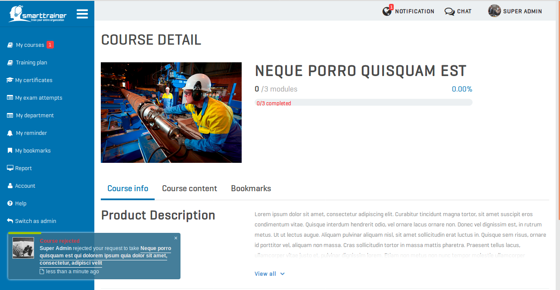

Can I create my own reminder?
Sure! You have module “My reminder” to manage all of these things. Whether creating a reminder for course, training plan or exam, etc.
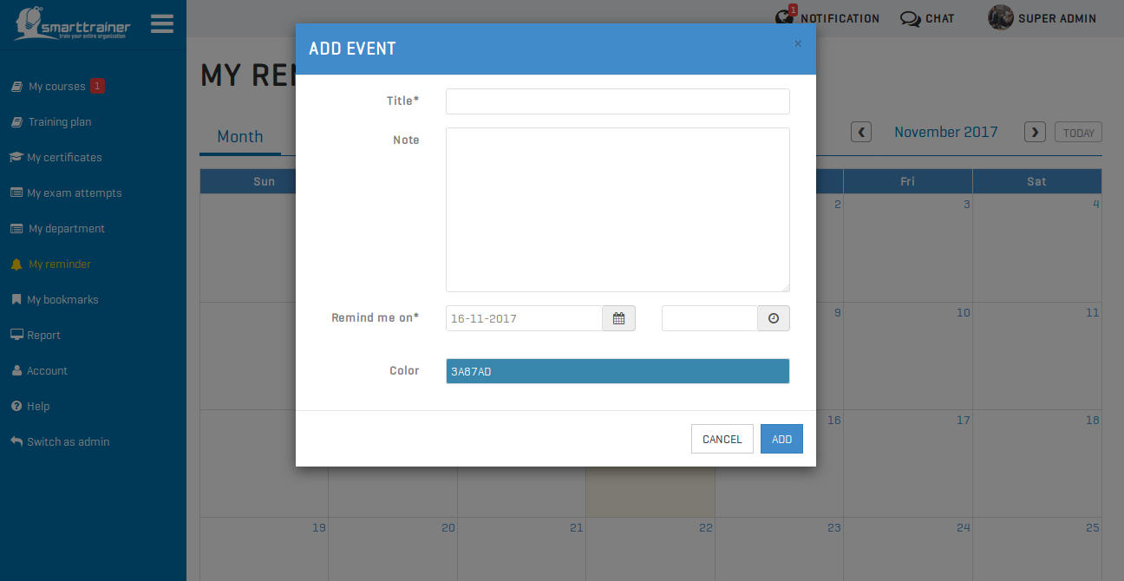
Together with this, you can receive real-time notification of all your setup reminder.
Hence, you do not need to be worried about missing these trainings!
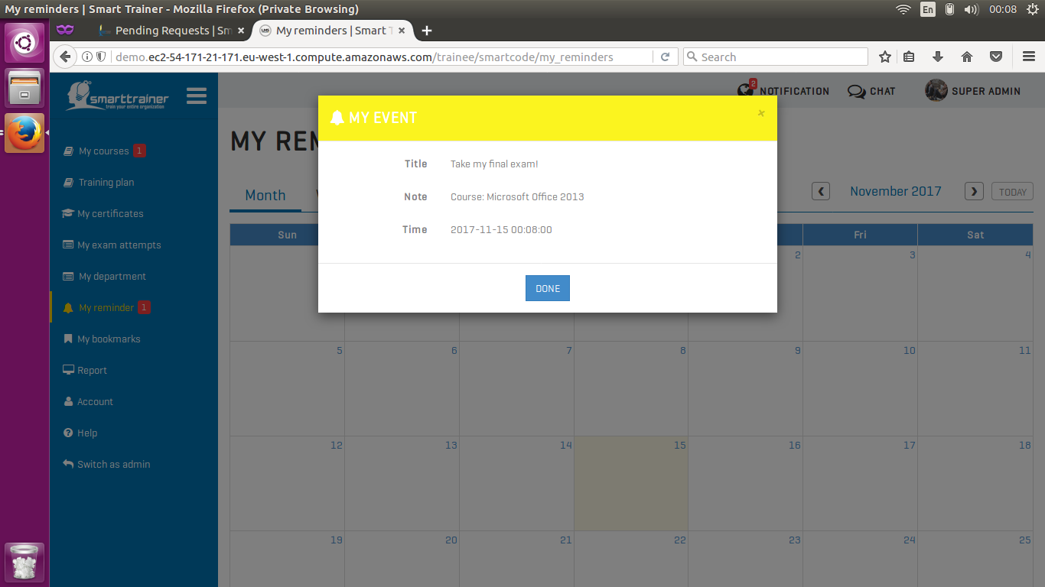

Can I view my bookmarks?
Of course! You can view your bookmarks within one course when you take training!
From this list, you can see the name of this bookmark and take action on it: view detail or remove it.
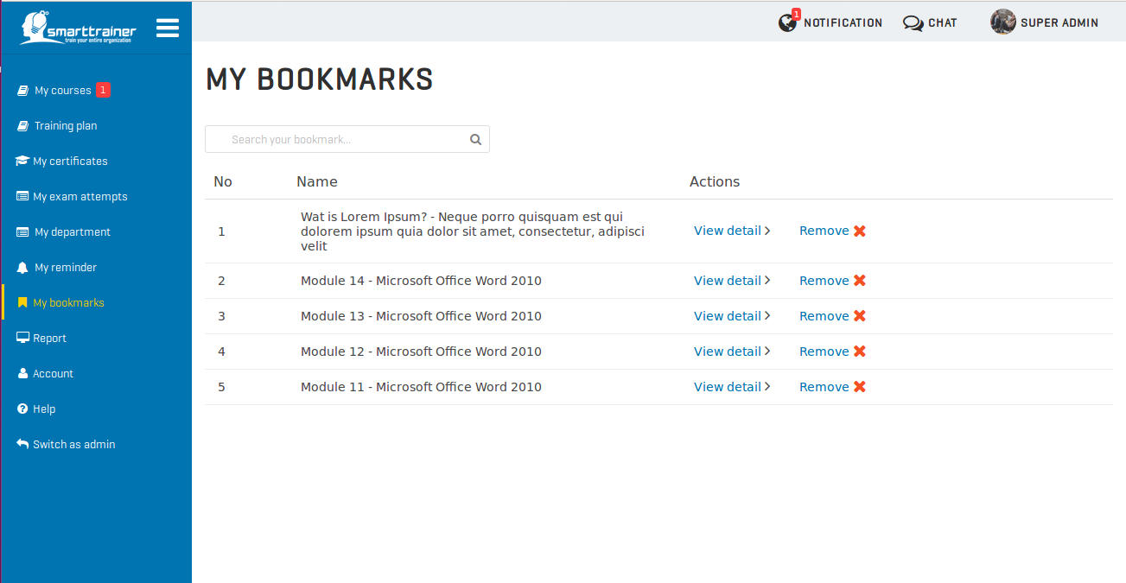

Can I change my account information?
You can change all your information except your email address which used for login, your location & department information.
Below are all the fields which you can make change:
- Password
- First name
- Last name
- Profile image
- Hired date
- Country
- Mobile phone
- Direct phone
- Fax
- Skype
- Address
- Job title
- Notification setting
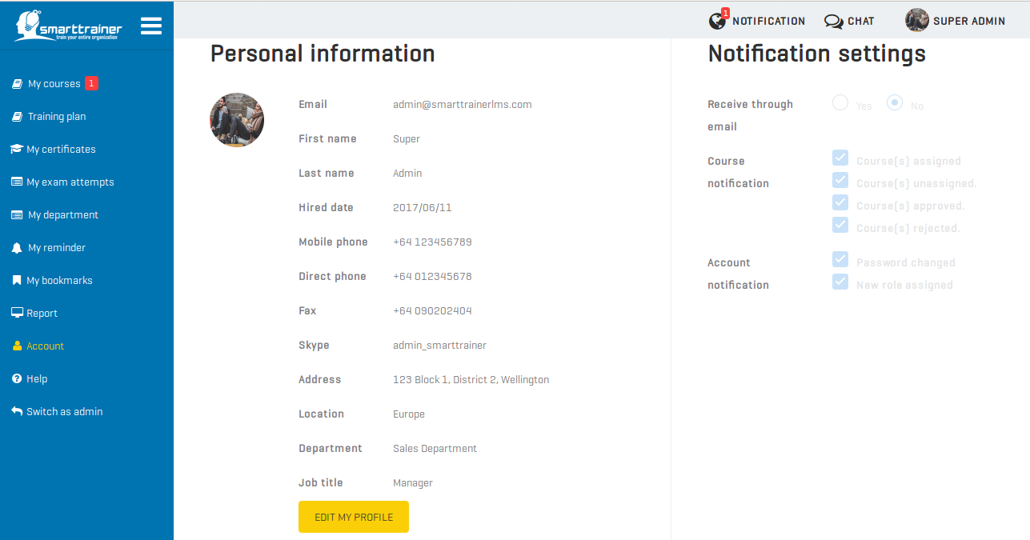

© Smart Trainer LMS
280 Great South Rd, Greenlane, Auckland 1051, New Zealand

