**Item 7: (et: 1h) done 22/12**

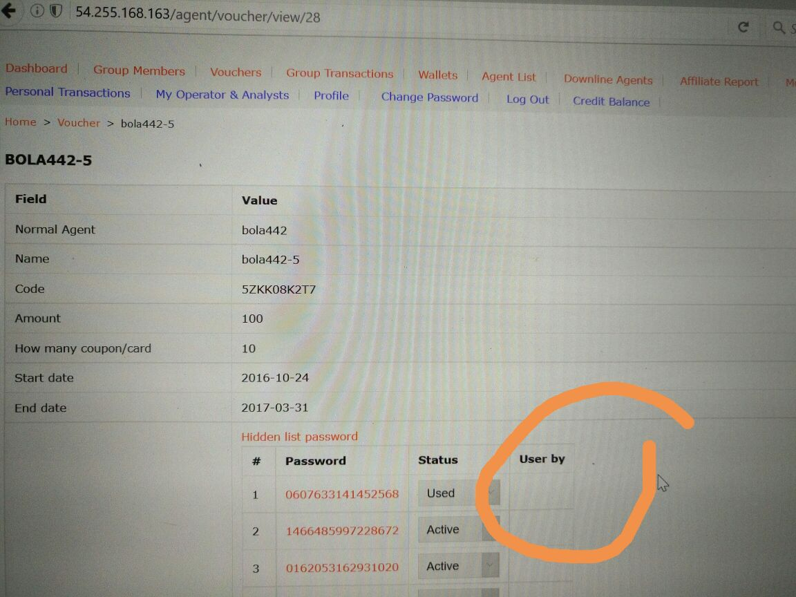

View page, show list password - need to show used by who for those that are used

**Item 8: (et: 3h) 22/12**

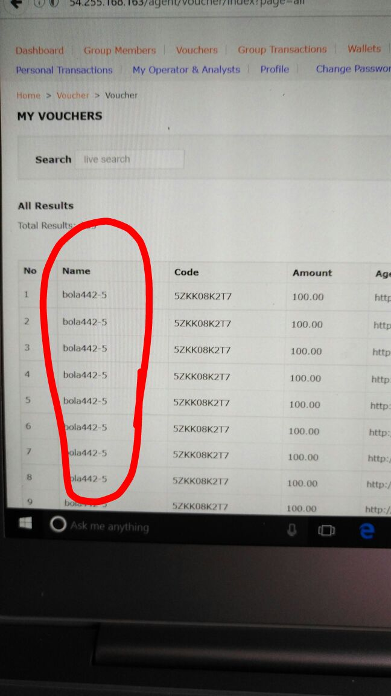

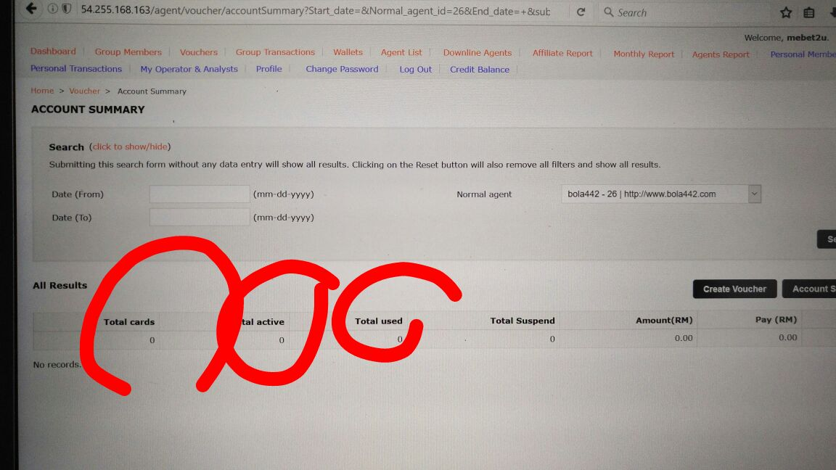

Account summary, is not functioning. All shows 0, even the bola442 has vouchers assigned / created to it.

**Item 9: (et:3h) 22/12**

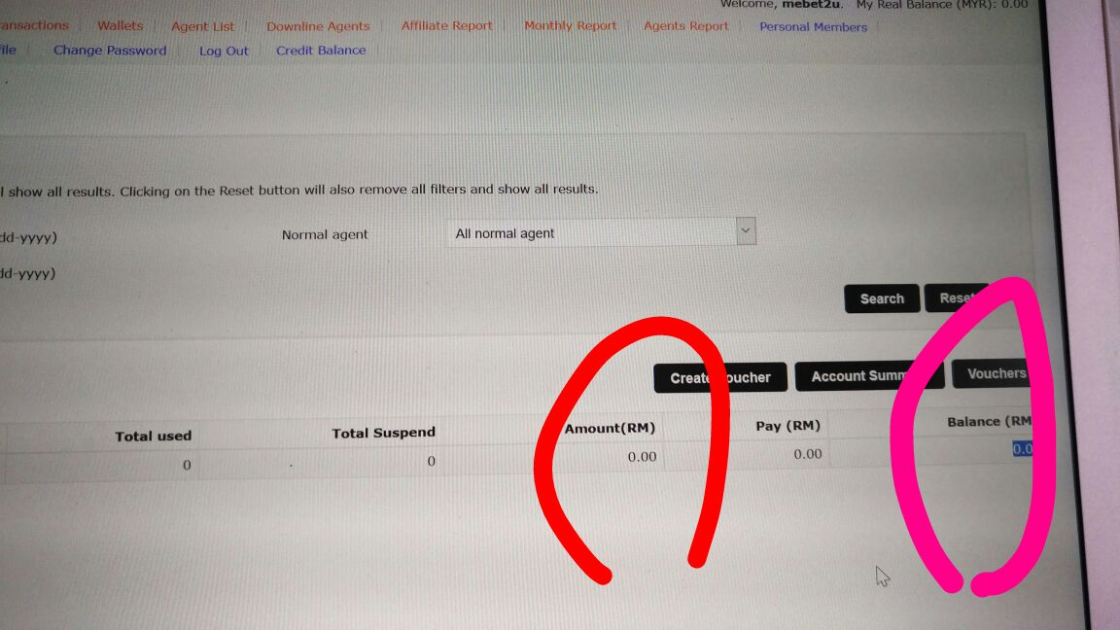

Under account summary , balance is also not correct, no amount, no balance even though previously we have the some vouchers assigned and used.

**Item 11: (et: 10h) done 23-24/12**

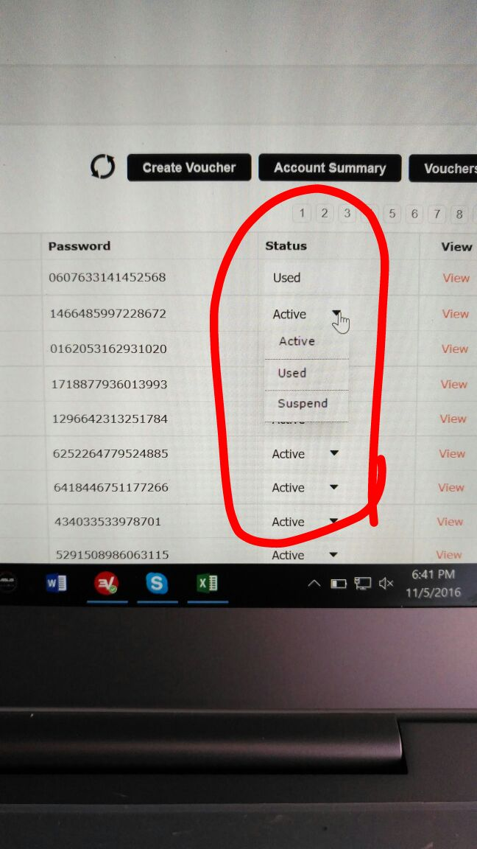

Currently, need to edit one by one. How can we edit by batch? E.g. If in case we created voucher code 123 with 500 cards, and we need to update all to Suspend status. How can we do it?

**Item 12: (et: 5h)(done)24/12**

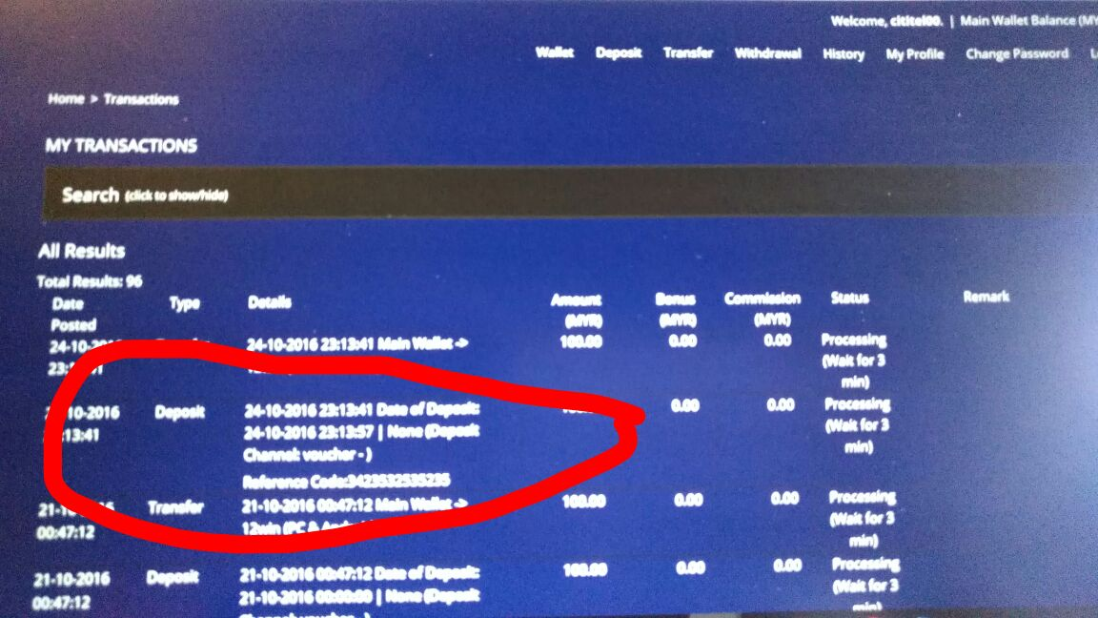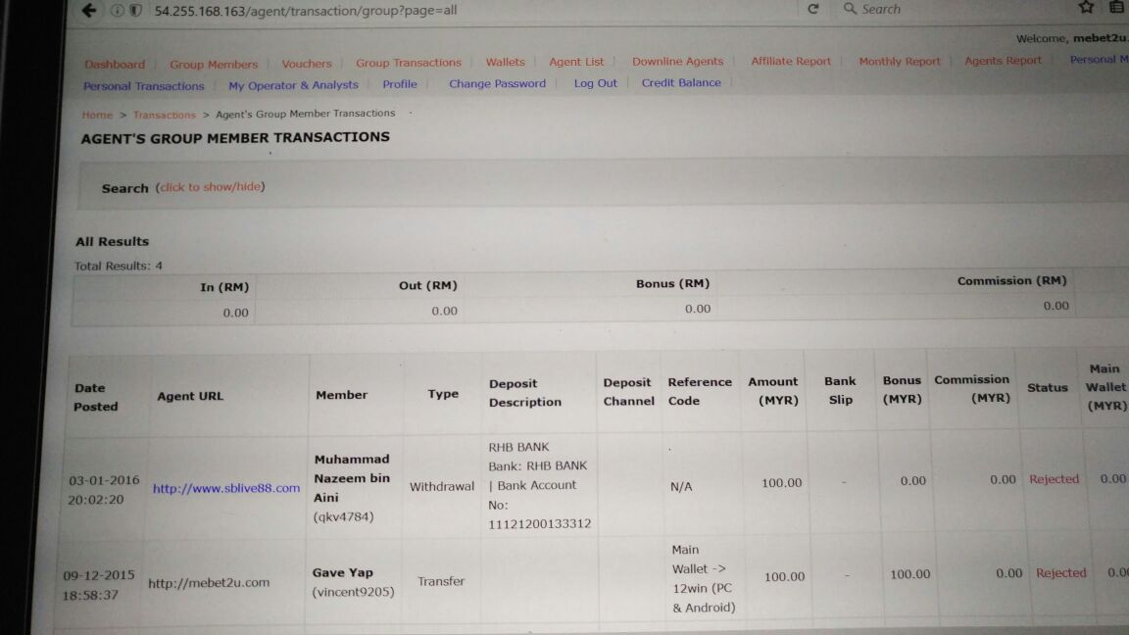

Upon submission of transaction (i.e. deposit by voucher), the group transaction page, should be showing the transaction once submitted by member. It is not there now. You can refer to the normal deposit pages how it works.

**Item 13: (et: 5h)25/12**

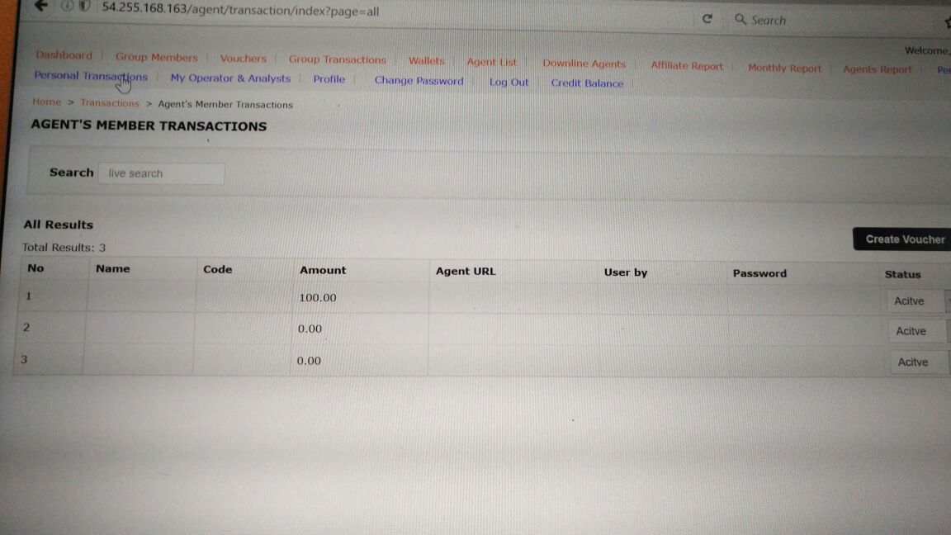

Platform admin, when clicked on "personal transaction" page it should go to the above page

**Items 31-32: (et: 16h) 26-27 (done)**

If you noticed, there is actually another way to login to agent, i.e as operator, and apart from the main account. You can create operator account from admin in admin area, or with agent main account. This operator account has a separate level of privileges - these are the restrictions mentioned in the excel sheet.

* basically, for operators it is very simple operators can only view no editing, no updating, no delete, no creation of vouchers
* they can view only what originally their agent can view